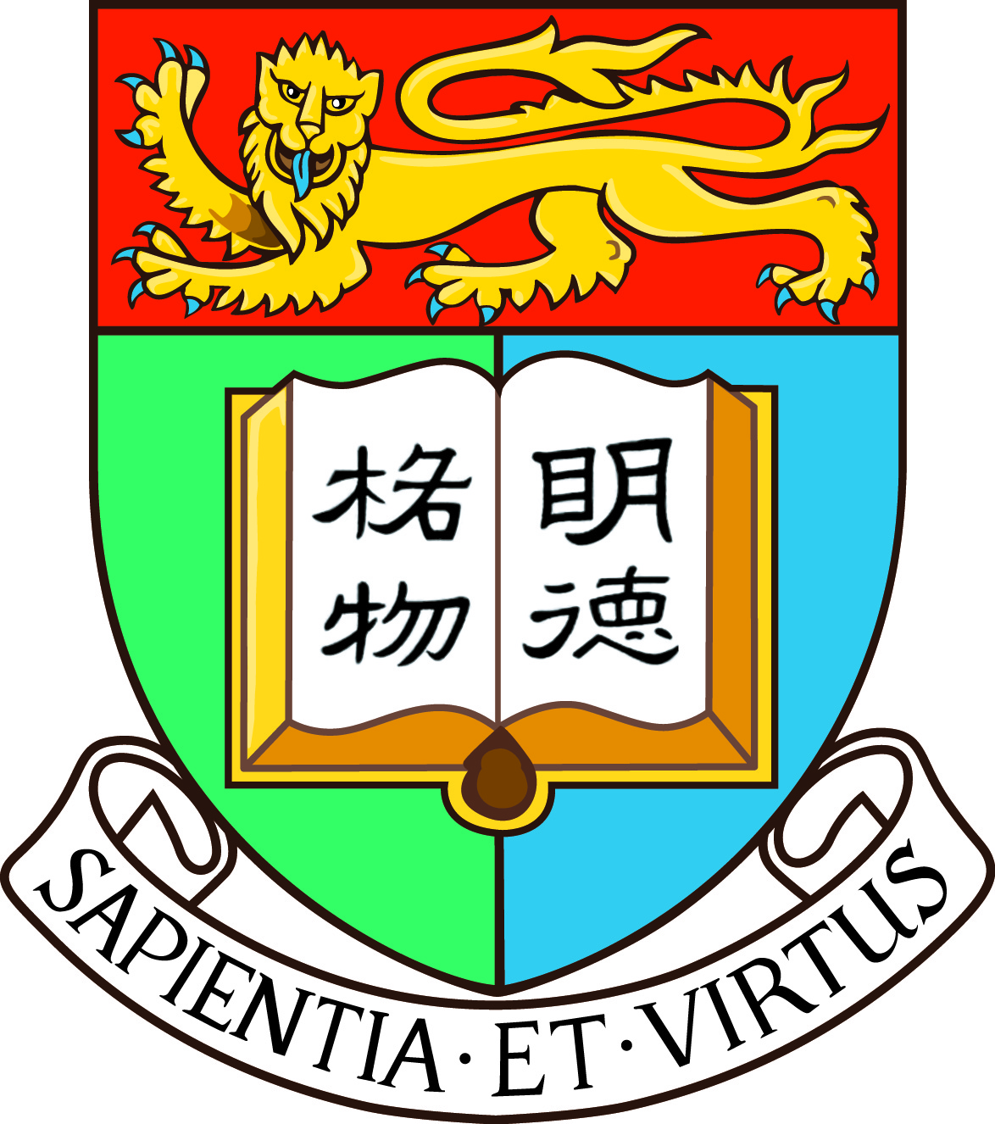

­»´ä¤j学´»´Á课µ{2012

简介
香港大学每年均举办一系列暑期课程，供国内及海外本科生报读。课程涵盖不同知识范畴，包括文学、工程、经济及工商管理及社会科学等，学术与趣味兼备，为本科生带来一个扩阔视野并体验港大校园生活的黄金机会。
其中港大文学院辖下的「人文艺术夏日学院」更量身订造一系列暑期英语课程，让国内本科生透过轻松有趣的教学模式，增强英语听说及写作能力，每年均获得国内本科生的踊跃参与。
有关暑期课程的详细资料，可浏览网页www.hku.hk/summer。

费用
- 学分课程的报名费为港币350元。而课程费用为港币4,260元(3个学分)至8,520元(6个学分)不等。(详请可参阅附件「本科生暑期课程概览」)。非学分课程报名费全免, 而课程费用请参阅www.hku.hk/summer。

- 获录取的同学另需支付来往香港之交通费用、签证费用(约港币800元正)及在港期间的个人开支等。(申请签证详情可登入连接：http://www.als.hku.hk/hkucao/svapp.php )

- 获录取的同学可申请入住港大学生宿舍，费用为港币120元一晚
(详请可登入http://www.als.hku.hk/summer/ckfinder/files/files/Accommodation_App_Form.pdf )。

报名程序
方法一: 网上报名
欢迎同学使用网上报名系统，同学可以上载有关的申请资料的电子档，不用邮寄，更加方便快捷。
网址: www.hku.hk/summer

方法二: 邮递报名
有兴趣的同学请把填好的报名表格连同所需资料于¬Û关ºI¤î报¦W¤é´Á前直接邮寄至香港大学，地址如下：
香港薄扶林道香港大学方树泉文娱中心地下国际交流中心
(信封面请注明 「香港大学暑期课程2012」)
报名的同学需递交以下申请资料 (英文版本):
- ¶ñ§´ªº课µ{报¦Wªí®æ
- ¨­¥÷证©ú¤å¥ó(°Æ¥»)
- ¤j学¦¨绩ªí (°Æ¥»)¡A¦p¤å¥ó¦}«D­^¤å¡A请´£¨Ñ­^¤åÂ½译
- ­^语¯à¤O证©ú (¦pTOEFL ©ÎIELTS ¦¨绩¡B¦³关证书©Î­^语¦Ñ师±À¯ò«Hµ¥)
- 报¦W费¥Î(´ä币350¤¸)ªº缴¥æªí®æ (¥t¥ó¤å¥ó编号 76/1211)

非学分课程
如若查询非学分课程可浏览网页www.hku.hk/summer

查询
香港薄扶林道香港大学方树泉文娱中心地下国际交流中心
电话：(852) 2241 5886 传真：(852) 2858 4986
电邮：summer@hku.hk 网页：www.hku.hk/summer

学分课程

Faculty of Business & Economics (经济及工商管理学院) - School of Economics and Finance
Course title | Course code | Credit | Schedule | Tuition fees | Application deadline
Global Business in Asia: New Horizons | N/A | 12 | June 17- July 14 | US$5,500  (USD 500 discount for application by Feb 1, 2012) | March 15

Faculty of Engineering (工程学院)
Course title | Course code | Credit | Schedule | Tuition fees | Application deadline
Engineering the Climate Change | ENGG1901 | 3 | July 9-13, Mon - Fri | HK$4,260 | March 15
Innovation Technology and Entrepreneurship in China | ENGG1903 | 3 | July 16 -21,  Mon - Sat  July 16:  Hong Kong  July 17 - 20: Shanghai  July 21:  Return to Hong Kong | HK$4,260 (Course Fee)  HK$5,000 (Tour Fee) | March 15

Faculty of Social Sciences (社会科学学院)
Course title | Course code | Credit | Schedule | Tuition fees | Application deadline
Asia as Global Future | FOSS4005 | 12 | June 24 – July 22 | US$ 5,000  (Early Bird : US$4,500 if applying before March 17) | March 31

Faculty of Arts (文学院) - Summer Institute in the Arts and Humanities
Course title | Course code | Credit | Schedule | Tuition fees | Application deadline
Film Art, Language and Culture | CLIT2083 | 6 | July 16 - August 10,  Mon - Fri, 14:00 - 17:00 | HK$8520 | March 1
Highlights of Chinese Dynasties | ARTS0012 | 3 | June 25 - July 6,  Mon - Fri, 10:00 - 13:00 | HK$4,260 | March 1
English Enhancement through Fine Arts Appreciation | ARTS1002 | 3 | July 30 - August 10,  Mon - Fri, 10:00 - 13:00 | HK$4,260 | March 1
English: Strategies for Confident Conversations and Presentations (Session 1) | ARTS1004 (Session 1) | 3 | July 16 - July 27,  Mon - Fri, 10:00 - 13:00 | HK$4,260 | March 1
English: Strategies for Confident Conversations and Presentations (Session 2) | ARTS1004 (Session 2) | 3 | July 30 - August 10,  Mon - Fri, 10:00 - 13:00 | HK$4,260 | March 1
English for Effective Communication: Business Simulations and Negotiations | ARTS1006 | 3 | July 16 - 27  Mon - Fri, 10:00 - 13:00 | HK$4,260 | March 1
Divos and Divas – Revolutionary Music of the Latin American World and the Influence of Che Guevara | ARTS1007 | 3 | July 16 - 27,  Mon - Fri, 10:00 - 13:00 | HK$4,260 | March 1
Critical Discussions on China | ARTS1008 | 3 | July 30 - August 10,  Mon - Fri, 10:00 - 13:00 | HK$4,260 | March 1
An Introduction to Language and Linguistics | ARTS1009 | 3 | July 16 – July 27, 2012; Mon to Fri, 2:00 p.m. – 5:00 p.m. | HK$4,260 | March 1
Creative industries in East Asia (Hong Kong, Taiwan, Korea and Japan) | ARTS2050 | 3 | July 27 - August 10,  Mon - Fri, 14:00 - 17:00 | HK$4,260 | March 1
Chinese as a Foreign Language I (Part I) | CHIN1501 | 6 | June 25 - July 20,  Mon - Fri 14:00 - 17:00 | HK$8,520 | March 1
Chinese as a Foreign Language II (Part II) | CHIN2501 | 6 | June 25 - July 20,  Mon - Fri 14:00 - 17:00 | HK$8,520 | March 1
Chinese as a Foreign Language III (Part III) | CHIN3501 | 6 | June 25 - July 20,  Mon - Fri 14:00 - 17:00 | HK$8,520 | March 1

Faculty of Science (科学院)
Course title | Course code | Credit | Schedule | Tuition fees | Application deadline
Linear Algebra  Eligibility  (For Form 7, Senior Secondary 1-3 students from local (or  equivalent), and students in lower forms with strong interest in  mathematics) | MATH1111 | 6 | July 7 - August 25; Sat only, 09:00 - 16:30 | HK$4,260 | May 4

非学分课程
Faculty of Architecture («Øµ®学°|)
Course title | Course code | Schedule | Eligibility | Tuition fees | Application deadline
Career Discovery in Architecture | ARCH0003 | July 9- July 27, 9:30-17:00 | Form 5-7 students from local/ Mainland/ overseas secondary schools  Undergraduates from overseas universities  as long as the students have not taken Architecture courses before | HK$12,500 | TBA

Faculty of Science (科学院)
Course title | Course code | Schedule | Eligibility | Tuition fees | Application deadline
Junior Science Institute (JSI) | JSI | July 17, 2012 (Tue)  July 24, 27, 31, 2012 (Astronomy Workshop) | Age: 16 or above  F4, 5, 6, 7 students from local secondary schools | HK$200 deposit | May 31

General Education Unit (通识教育部)
Course title | Course code | Schedule | Eligibility | Tuition fees | Application deadline
Summer School for Effective Leadership 2012 | SSEL | July 19 – 28, mandatory 10-day-9-night programme | Secondary 4 / 5 / 6 / 7* students from local / Mainland / overseas* | HK$8,000 | May 11
Crimson Summer Exchange | CSE | July 14 - 26 - in Beijing  July 29 - August 10 - in Hong Kong | Age 14 - 18 | please refer to http://cse.cccef.org.hk | April 16

Faculty of Engineering (工程学院)
Course title | Course code | Schedule | Eligibility | Tuition fees | Application deadline
Engineering Summer Camp 2012 | ESC | July 23-26 (Monday to Thursday) | Form 5, Form 6, and Form 7 students from local and overseas secondary schools | HK$1,200 | June 8

Faculty of Dentistry (牙医学院)
Course title | Course code | Schedule | Eligibility | Tuition fees | Application deadline
Dentistry and Oral Health (Day Programme) | DOH day | July 23-27 | Secondary 4/5/6/7 (Grades 10-13) students from local/overseas  Undergraduates/graduates from overseas universities | HK$2,500 | June 1
Dentistry and Oral Health (Residential Programme) | DOH residential | July 22-28, |  | HK$3,000 | June 1

