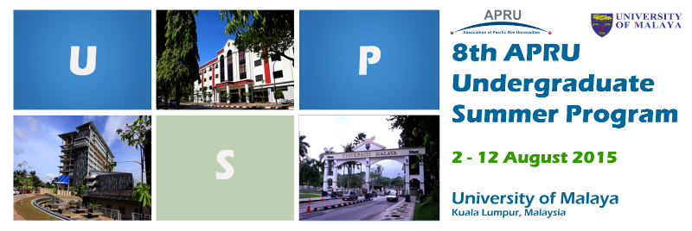

"Developing Future Global Leaders of the Pacific Rim: The Different Facets of Leadership"

Photo by: International Student Centre, University of Malaya
PROGRAM HIGHLIGHTS
The 8th APRU Undergraduate Summer Program (USP) will be hosted by the University of Malaya's International Student Centre in Kuala Lumpur, Malaysia from 2 to 10 August. Focusing on the different facets of leadership and various immersion activities, the 10-day program to will engage participants in dynamic group discussions and seminars.
Students can learn from presentations and talks on:
- Governance and Public Policy;
- Leadership in Non-Government Institutions;
- Leadership in the Financial Sector;
- Student Leadership, Empowerment and Community Engagement; and
- Women and Leadership, among others.
During the course of the program, students will also participate in a special leadership workshop and create a 'leadership canvas' as part of their personal development.
Students will create and present project proposals and apply their key learnings from the program.
Download the latest preliminary program here.

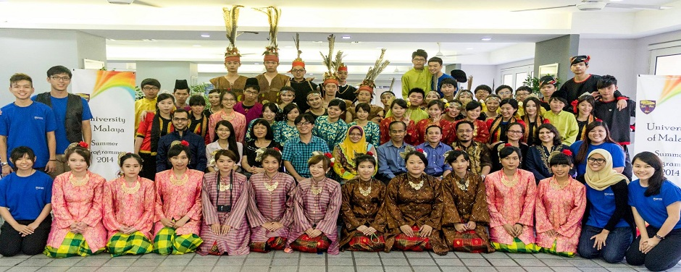
Photo by: International Student Centre, University of Malaya
PARTICIPATION IS OPEN TO APRU STUDENTS!
The multidisciplinary format the program encourages the participation and engagement of students from various disciplines. Students enrolled in an undergraduate program at an APRU member university are eligible to apply for the USP. Students should apply through the relevant department or office within their respective institution.
APRU member universities may nominate up to three students for the USP, however the participation will be capped at 60 students to optimise the academic and experiential quality of the program.
The registration form can be downloaded here.

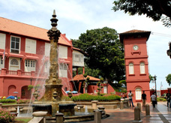
Photo by: Malaysia Tourism Promotion Board (Right: The Stadthuys, Malacca)
EXPERIENCE MALAYSIA
Students will have the opportunity to immerse themselves in the diverse Malaysian culture during a visit and homestay at Malacca, a UNESCO World Heritage site and one of Malaysia's historic towns.
An optional trip to Taman Negara National Park has also been arranged after the USP from 12 to 15 August. (N.B. See program for the tour itinerary.)

FEES
Registration Fee: USD 450
Inclusive of:
- Shared accommodation at University of Malaya's International House and airport transfers on 2 and 12 August and (travel details must be indicated in the registration form).
N.B. Participants arriving or leaving at a different time schedule are to arrange for their own transport. Information on location will be provided subsequently.
-Meals as indicated in the program
-Program Materials
-Networking and cultural activities during the program
Optional trip to Taman Negara: USD 350
Inclusive of:
- (Shared) accommodation and transfers
N.B.
Please note that the refund policy is no longer be applicable as the payment date has been extended.
Personal expenses including travel insurance are to be borne by participants and/or sponsoring institution.

KEY DATES (EXTENDED)
Registration has been extended till 15 June. Payment can be made till 30 June.

CONTACT INFORMATION
For general enquiries, please contact the USP 2015 Local Organising Committee at the University of Malaya, c/o:
Ms Vigneshree King
Assistant Registrar
International Student Centre (ISC)
Level 1, Block G, Perdanasiswa Complex
University of Malaya
50603 Kuala Lumpur, Malaysia
Tel : +603-79677716/7717
Fax : +603-79677710
Email : vigneshking@um.edu.my
Website: http://isc.um.edu.my

