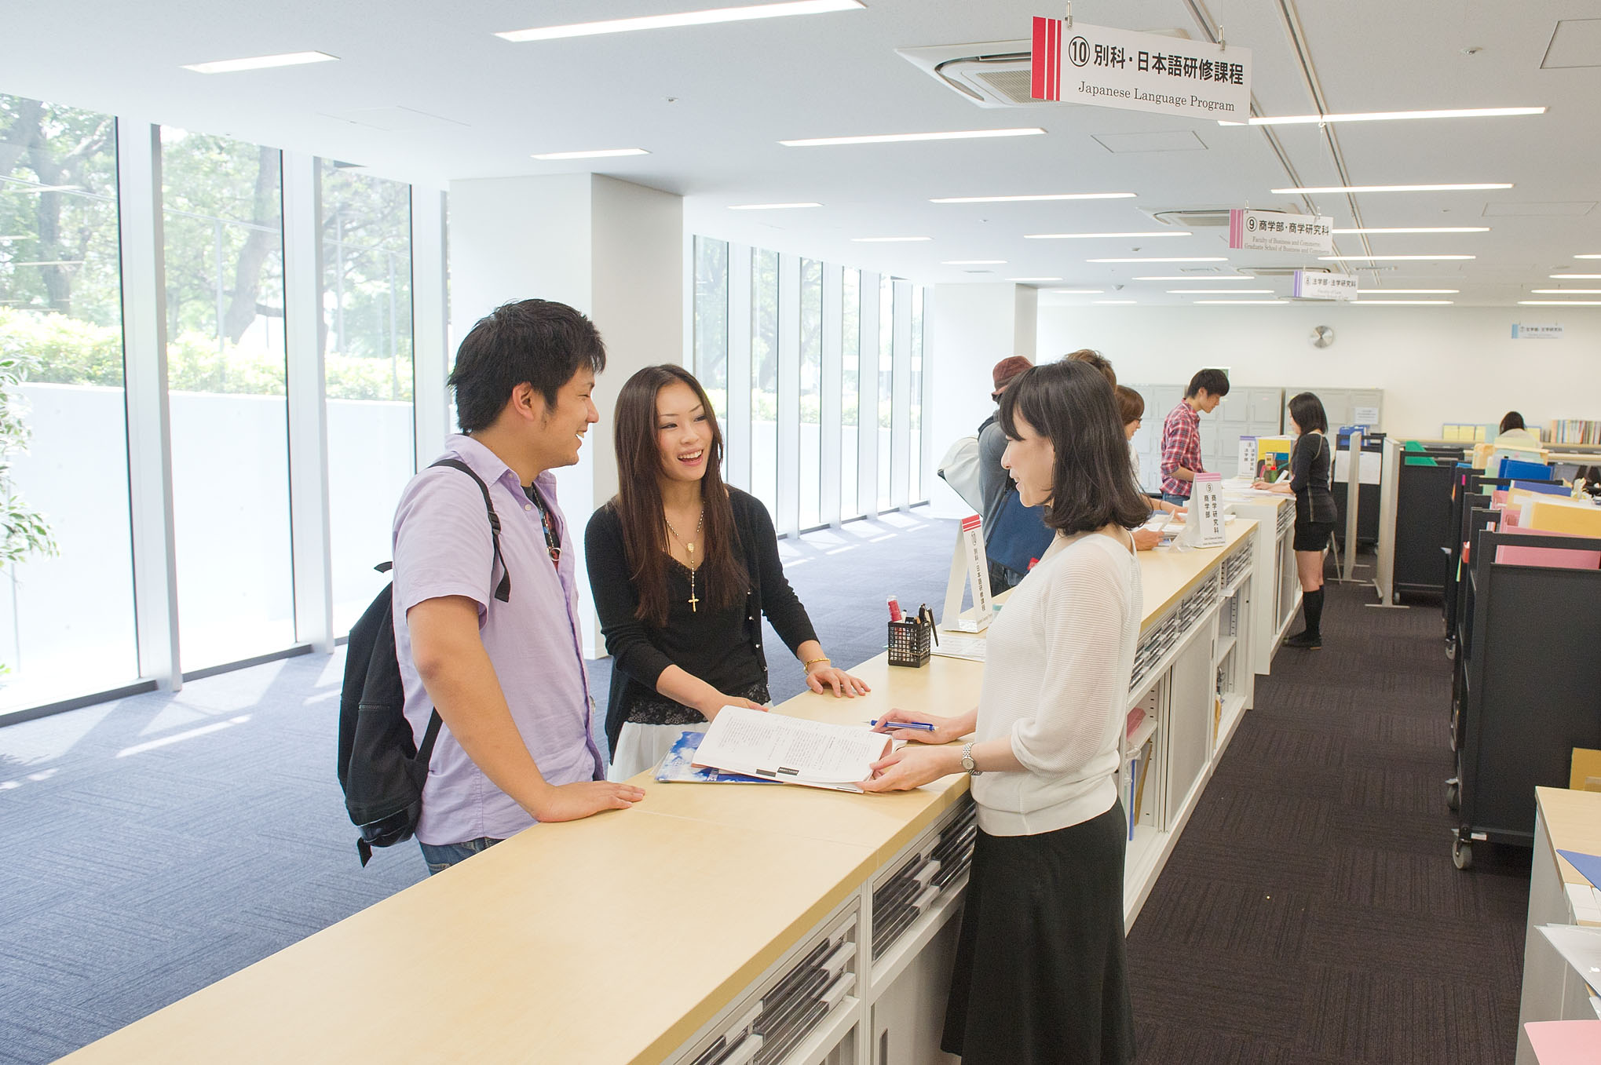

庆应义塾大学创业者育成项目
2017 年 2 月 9 日（周四）- 2 月 18 日（周六）

庆应义塾大学创业者育成项目
项目概况
本项目以集中课程的方式，由中国各地报考的25名优秀大学生和庆应义塾大学15名优秀的在校学生共同参加。在帮助同学们掌握创业时必要的思维方式以及基础知识的同时，鼓励同学们在各自组成的小组中提出并讨论创业的创意。课程中，讲师会以面对着消费者严格要求的日本企业为例，讲授关于顾客价值的创造以及构建企业核心竞争力的知识。另外，项目主办方还邀请了有名的企业家、活跃在风投公司的投资家等经营方面的专家为大家讲授现实中的案例，加深大家的理解。项目的最后一天是商业创意大赛，针对大家的小组展示，讲师会给予相应的反馈意见。大家更可以通过与参加本项目与庆应义塾大学的学生的交流和文化体验，增进对异域文化的理解和交流。

大学介绍

庆应义塾大学是日本历史最悠久的私立综合性高等教育机构。主校区位于日本东京都中心的三田，是日本久负盛名的世界顶尖大学。
作为日本历史最为古老的综合私立大学的庆应义塾大学，在创始人福泽谕吉的指导和影响下不断发展，自1858年创建之后，至今在日本社会各个领域中均发挥着先驱领导作用。庆应义塾大学是日本超级国际化大学计划（Top Global University Project）A类顶尖校之一（即东京大学，京都大学，庆应义塾大学，早稻田大学，以及大阪大学）、亚太顶尖大学组织环太平洋大学联盟（Association of Pacific Rim Universities）六所日本成员校之一。其商科、政法、经济、医学等方面最为突出。此外，庆应义塾大学亦是全球500强企业CEO校友数世界排名第9的大学。庆应义塾大学培育了很多优秀的企业家，日本两千家最好的企业中至少十分之一的CEO出身于庆应义塾大学，因此有“企业家摇篮”之称，更被认为是把握着日本经济命脉和未来的中枢学府。有亚洲第一私立学府之称。

- 行程时间：2017年2月9日－2017年2月18日（10天）
- 申请对象：在读本科生，具备较强的英文沟通交流能力。
※ 英语要求CET 6级，并提交大学在校期间的成绩证明书。
成绩证明为参考是否能够参加本项目的重要评价标准。
- 课程语言：英语
- 上课地点：庆应义塾大学三田校区
- 项目认定：参加该项目学生可获庆应义塾大学项目结业证书
- 申请截止：2016年11月30日（定员25名 名满截止）

讲师介绍
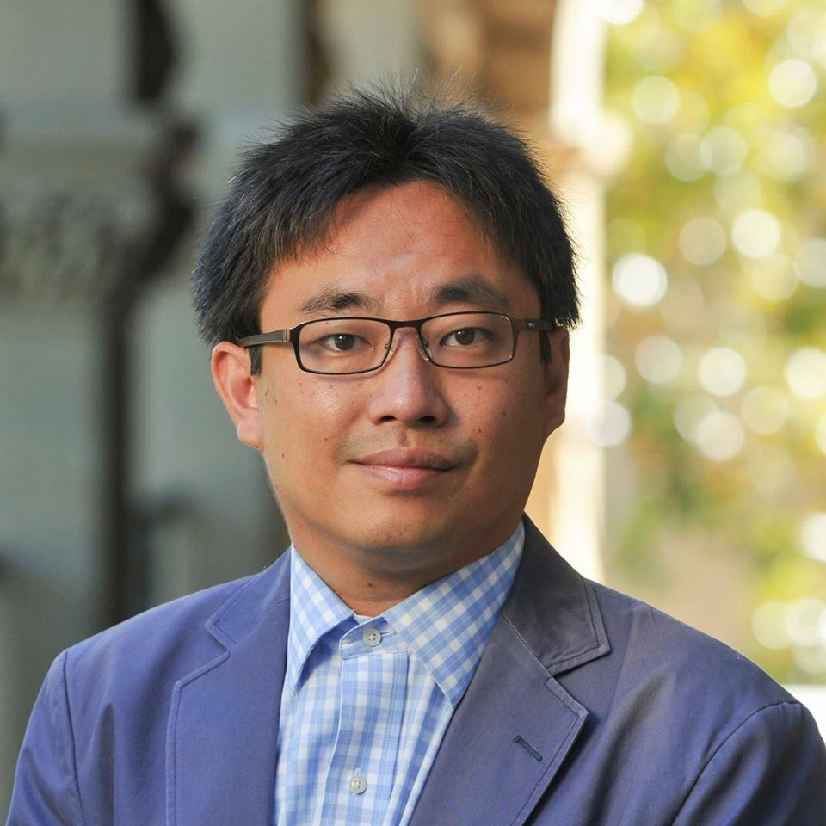
Kanetaka MAKI
(Assistant Professor, National Graduate Institute for
Policy Studies)
●Professional Career
Kanetaka Maki holds a Ph.D. in Management from the University of California, San Diego.
He also serves as Visiting Assistant Professor of University of California, San Diego and Affiliated Fellow at National Institute of Science and Technology Policy.
Prior to joining GRIPS, Maki has worked at Stanford University and Keio University.
His specialties are Science Policy and Entrepreneurship. His current research interests are "The success factor of university-based startups" and "Comparison study of innovation system between the US and Japan."
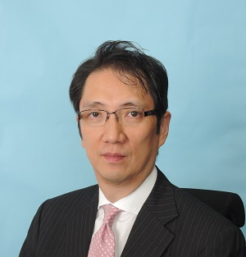

Naonori KIMURA
(Partner, Managing Director, Industrial Growth Platform, Inc.)

●Professional Career
Naonori Kimura’s activities include numerous advisory services such as corporate strategies including breakthroughs, strategy shifts and re-growth initiatives. He has advised clients on business management streamlining, structural reforms, financial strategy, new business development, M&A strategies, and cost competitiveness. Prior to IGPI, he launched a venture business, worked with NCR Japan and later at Towers Perrin and Arthur D. Little Japan.
He graduated from Keio University, School of Economics, and holds an MBA from the University of Leicester and an MS in Finance from the Lancaster University. He also completed AMP in Harvard Business School.

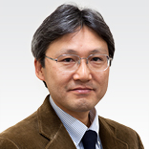
Masahiro OKADA
(Professor, Keio Business School)

●Professional Career
Masahiro Okada serves as Professor of Keio Business School. Earlier in his career, he worked for Honda Motor Co., Ltd. and Arthur D. Little Japan, Inc. He also worked as a fellow at MUSE Associates, Inc., Palo Alto, CA.
Okada graduated from Waseda University, School of Political Science and Economics, and holds an MBA from the Graduate School of Business Administration, Keio University and a Ph.D. in business administration from Fisher College of Business, the Ohio State University.
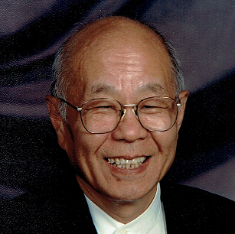
Toshikata AMINO
(Executive Vice President (Retired), Honda of America Mfg., Inc.)

●Professional Career
Toshikata Amino serves as a fellow of Ohio State University.
He served as Executive Vice President of Honda of America Mfg., Inc.
Former Adjunct Professor, Keio Business School
Director, Cross Cultural Management Institute
Hitoshi SUGA
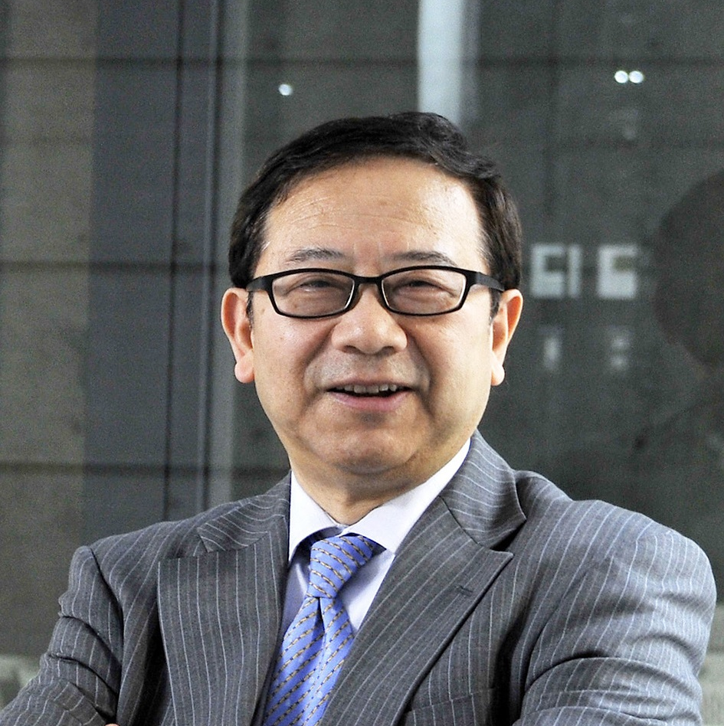

(Special Advisor to President (ex-Vice Chairman),
Tully's Coffee Japan Co., Ltd.)
●Professional Career
Mr. Suga is one of the most experienced and prominent Japanese venture capitalists and has substantial proven track record in Japan and the global venture investment, who presently serves as Professor and Associate Dean, Yamanashi Gakuin University, International College of Liberal Arts (iCLA) and a few other highly prestigious universities in Japan teaching entrepreneurship. He has spent total 24 years of his career at Mitsui & Co. (Mitsui Bussan). Since 1988 until 1996, he was responsible for planning and implementing various successful cross border and domestic M&A deals at Mitsui Bussan's Corporate Planning Div., and its clients totaling more than $900 Million. In 1996, he founded and became President and CEO of MVC Corporation (Presently Mitsui Global Investment), a global venture capital/PE arm of Mitsui. While at MVC Mr. Suga has identified and invested in various fast-growing start-up companies and served as board members of several of MVC’s portfolio companies, 5 of which have successfully gone public and 2 achieved successful trade-sales. One of the most successful investments he has made is Tully’s Coffee Japan (TCJ) for which Mr. Suga has acted as its angel investor through MVC, Vice Chairman and a board member, and mentor to its Founder/President, Mr.Kouta Matsuda, which went NASDAQ-J (now JASDAQ Market) in the shortest record of 2-1/2 years after the incorporation among all the public food companies in Japan. In November, 2006, as its Vice Chairman, he has played a major role to successfully sell the majority control of TCJ to ITO EN, LTD., a major TSEC-I listed green tea and other beverages company. He still serves as TCJ's Special Advisor to President while having various board memberships and advisory functions of emerging and high growth companies. In 2008, Mr.Suga received the Minister of Small Business Agency Award from METI(Ministry of Economy, Trade & Industry)-affiliated “Japan Venture Award 2008”(Nurturing Entrepreneurs Section)
Mr. Suga holds an MBA degree from Harvard Business School and BA degree from Waseda Univ. (School of Political Science and Economics).
Nobuaki KITAGAWA
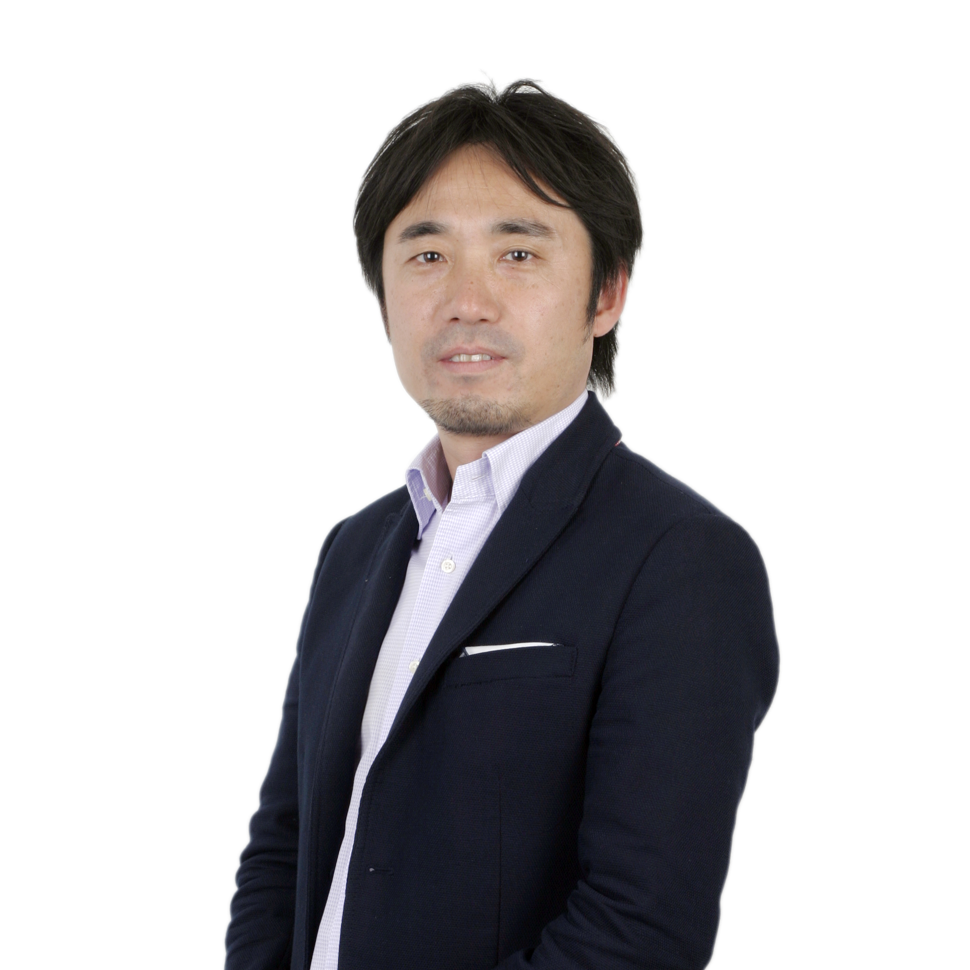

(Managing Director, CEO of CyberAgent Ventures China Co.,Ltd.)
●Professional Career
Nobuaki Kitagawa is responsible for all of the company's investments in China, Taiwan,
SEA and Korea. Since joining to CyberAgent Ventures（CAV) in 2006, Kitagawa has led international expansion from
no investment outside Japan then to more than 65 overseas investments including Youku-Tudou (China, NYSE: YOKU), Kakao Corp (Korea: 043720KQ), VIPABC (China), Tokopedia (Indonesia) and Vatgia,com (Vietnam). Under his leadership, CyberAgent Ventures has invested about US$65M into the region since 2006. He also has build his overseas investment team from zero in 2006 to 20 professionals located in the five countries at present.
Prior to CAV he had more than 10 years' experience in the telecom industry working for Japan's NTT DoCoMo.
He graduated from Hitotsubashi University, Economics, and holds an MBA from Georgetown University in the United States.
He has been living in China since 2008, currently based in Shanghai with his family.
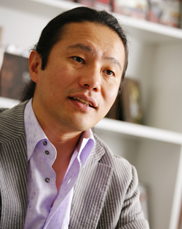
Shinichiro ISHIKAWA
(Founder and President, GONZO K.K.)
●Professional Career
Shinichiro Ishikawa graduated from University of Tokyo, MSc in Physics (Astrophysics
and Cosmology), the School of Science, and holds an MBA from INSEAD (the European Institute of Business Administration) with honors: Dean's List and The Lister Vickery Memorial Award in Entrepreneurship
Ishikawa joined The Boston Consulting Group (BCG) in 1991 and was involved in many projects related to new business development, corporate strategy/vision and alliances in the high-tech telecommunications and media convergence arena.
In 1996 he founded Digimation while working at BCG. His partner ran the company until he resigned from BCG in 1999 and joined Digimation as President. After merging with GONZO in 2000 to create GONZO DIGIMATION HOLDING K.K. (GDH), he became President and CEO. In 2008, GDH changed its name to GONZO K.K. and he currently serves as Representative Director and Founder of GONZO.
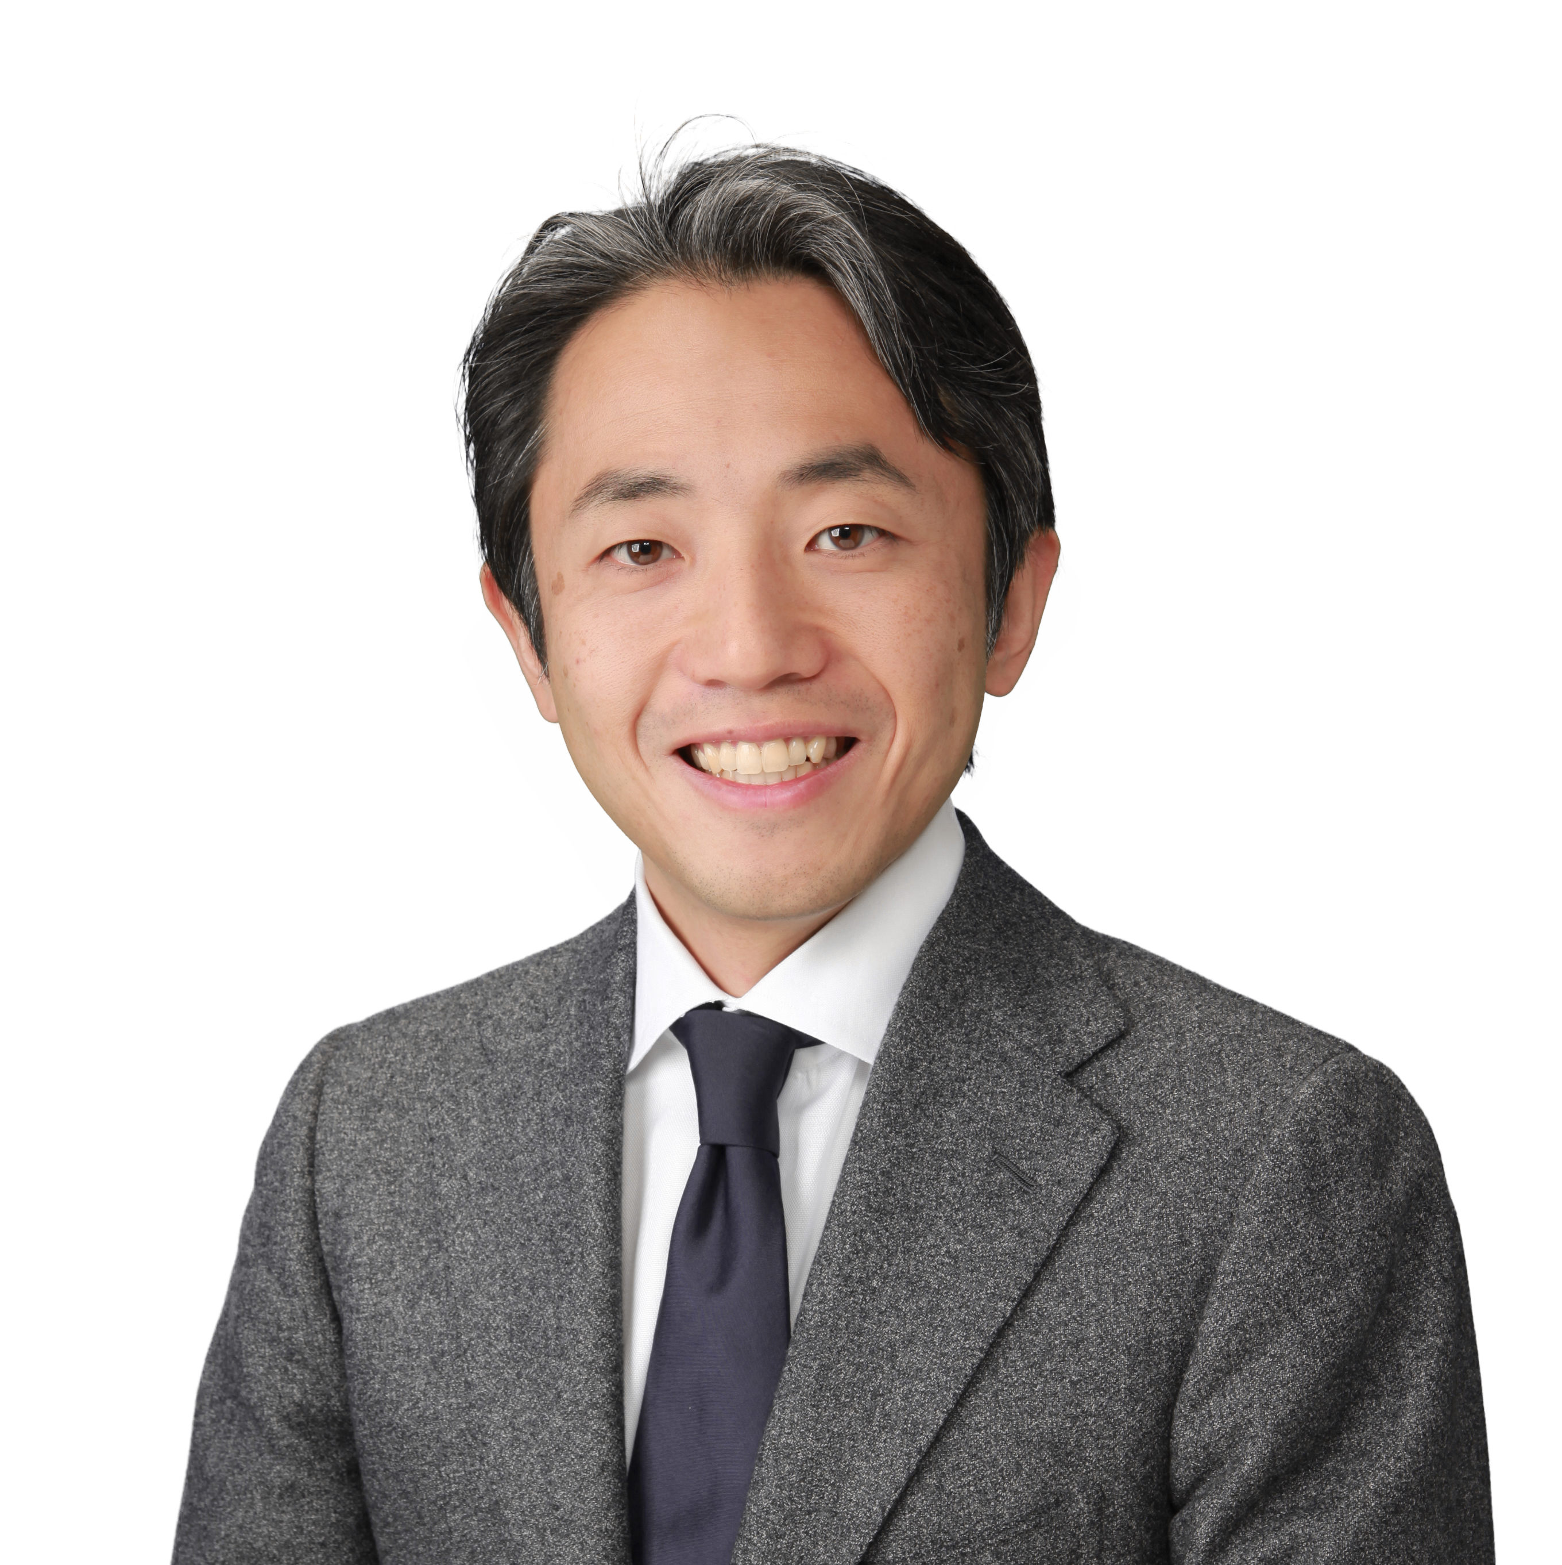

Kotaro YAMAGISHI
(CEO, Keio Innovation Initiative, Inc.)
●Professional Career
Kotaro Yamagishi serves as CEO of Keio Innovation Initiative, Inc.
He co-founded GREE in December 2004, and now serves as the Company's director (part-time). Earlier in his career, he was editor-in-chief of CNET Networks Japan (now ASAHI INTERACTIVE, Inc.) prior to which, he worked at Nikkei Business Publications, Inc. He graduated from Keio University, Economics.

参访企业介绍

ASKUL Corporation
Askul Corporation 是日本最大规模的电商企业。公司名来源于日语「明日来る」，意为”明日送达”。公司自1997年创立至今，主营办公用品的线上销售，在2004年新增了医护用品的销售业务。2005年又新增了专门以医疗机构为对象的医用材料销售业务。目前，公司共对外销售20000余种商品。由于公司秉承“为客户不断提升自己”的理念，采用独特的设计理念并严格控制品质，打破了传统的沉闷生活办公方式，开启了快乐办公的新潮流。
日程表

庆应义塾大学创业者育成项目
月日 | 09:50-10:00 | 10:00-12:00 10:00-12:00 | Lunch | 13:15-15:15 | 15:30-17:00
2月9日（周四） |  | 从国内出发  乘坐国际航班抵达日本东京  当晚举办欢迎会
2月10日（周五） |  | 参观浅草寺，秋叶原，台场
2月11日（周六） |  | 日本文化体验（茶道、浴衣）
2月12日（周日） |  | 自主研修
2月13日（周一） | Welcome Remarks | What is Entrepreneurship？  Kanetaka MAKI  (Assistant Professor, National  Graduate Institute for Policy Studies) |  | Value Proposition/ What is Your Value  Proposition?  Naonori KIMURA (Partner,Managing Director,  Industrial Growth Platform, Inc. (IGPI)) | Group Work  （发表准备）
2月14日（周二） |  | Writing Your Business Plan: Business Model and Business Strategy  Masahiro OKADA (Professor, Keio Business School) |  | Innovative Management  - Honda Way; Some Suggestions for  Entrepreneurs  Toshikata AMINO (Executive Vice President (Retired), Honda of America Mfg., Inc.) | Group Work  （发表准备）
2月15日（周三） |  | Ups & Downs of Tully's Coffee Japan Co.,Ltd. ..and Beyond..  Hitoshi SUGA (Special Advisor to President(ex- Vice Chairman), Tully's Coffee Japan Co.,Ltd.) |  | ＜企业访问＞ ASKUL Corporation
2月16日（周四） |  | Fund Raising, What are Investors Looking For?  Nobuaki KITAGAWA (Managing Director, CEO of CyberAgent Ventures China Co.,Ltd.) |  | Can Anime Conquer the World?  Shinichiro ISHIKAWA (Founder and President, GONZO K.K.) | Group Work  （发表准备）
2月17日（周五） |  | Group Work （发表准备） |  | Business Idea Competition & Wrap- up  Kotaro YAMAGISHI (CEO, Keio Innovation  Initiative, Inc.) | 结业式  送别会
2月18日（周六） |  | 搭乘航班返回国内

关于本行程说明: 调研内容及安排，以庆应义塾大学最终安排为准。可能存在部分调整。

项目费用 ：185000日元（约12000元人民币）
*以上日元对人民币汇率仅供参考,请以当日银行官方价格为准
费用包括：报名费，学费，海外医疗保险费，邀请函国际邮递费，欢迎欢送会餐费，住宿费，课程期间交通费
不包括的费用：国际机票费，个人护照办理费，签证手续费，国内交通费，餐费，行李超重费，自由活动时产生的费用，个人购物消费，其它“费用包括”以外的费用。
不包含费用说明：国际往返机票费：约4000元人民币（含税）参加学生统一购买
餐食费用：调研期间不统一组织就餐，同学自行选择大学食堂或其他地点就餐。
报名方式：
1、 登陆http://duanqi.xf-world.org/在线报名
2、 全国报名热线400-600-2900
3、 填写招生简章末页的报名表，并发送至邮箱duanqi@xf-world.org
4、 合作校学生请直接向所在大学的负责老师报名
（合作校列表请见http://duanqi.xf-world.org/a/hezuodaxue/guonahezuodaxue/）

附件1
2017年庆应义塾大学创业者育成项目报名表
个 人 信 息
*姓 名 |  |  | *性别 |  |  | *汉语拼音（大写） |  | <请确保所填拼音与护照信息一致>
*出生日期 | <请确保所填生日与护照信息一致> |  |  |  |  | 民 族 |  | *户口所在地
*身份证号 |  |  |  | *出生地 |  | <请确保所填信息与护照一致> |  |  | *GPA成绩
联 系 方 式
<请尽量详尽地填写 以便于我们与你取得联系！>
*通讯地址 | <请填写能够接收快递的地址 以便于在签证办理阶段邮寄材料> |  |  |  |  |  |  | 邮政编码
*手机号码 |  |  |  | *家庭电话 |  |  |  | 宿舍电话
*E-mail |  |  |  |  |  |  |  | *QQ号码
学 习 情 况
*就读学校 |  |  |  |  |  | *所在院系
*专 业 | （ ）年级 |  |  |  |  | *学 历 |  | <填写提示：专/本/硕/博>
担任职务 |  |  |  |  |  | *英语水平
奖惩情况
出 入 境 情 况
<无护照者 请配合于报名后尽快办理；护照有效期不满半年者，请配合尽快办理延期手续！>
是否持有护照 |  |  |  | *护照号码 |  |  |  | *护照有效期 |  | <精确至年月日>
*出入境记录 |  |  |  | *拒签史及理由 |  |  |  | *护照签发地
*项目为必填内容，请务必确保所有信息真实有效 |  |  |  |  |  |  | 本人签名

报名热线：400-600-2900 报名邮箱：duanqi@xf-world.org

