
American Studies Summer Program
For Zhejiang University Undergraduates
“Business and Entrepreneurship in America”
July 11 – August 7, 2014

你好 欢迎

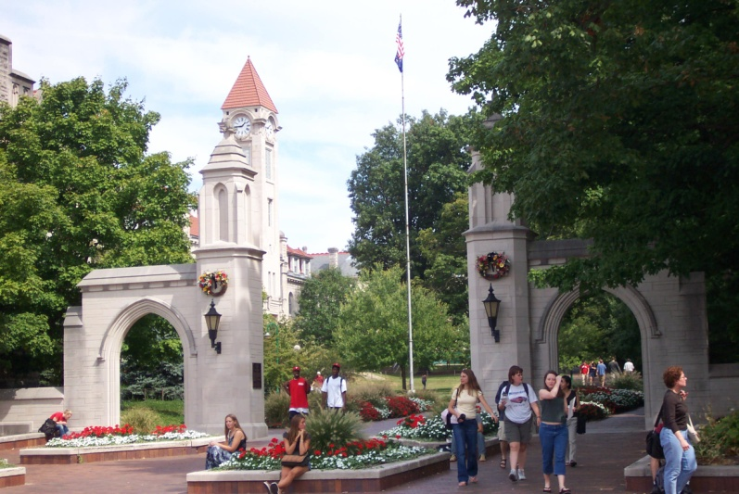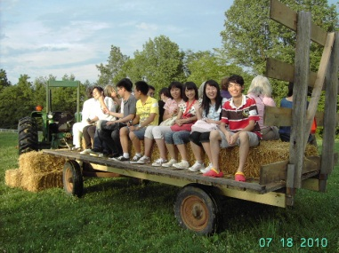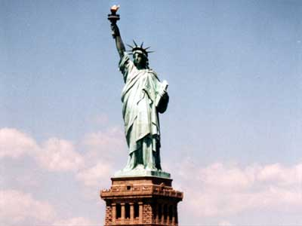

Indiana University (IU) offers students a rich tradition and excellent academic opportunities. IU offers more than 200 master’s, doctoral and graduate professional degree programs and is a leader in information technology.

Established in 1820, IU Bloomington is known around the world for its contributions in research and the arts and its top-ranked academic programs.

Many IU programs are ranked by various publications among the
TOP 10 in the United States include:
analytical chemistry, applied health science, business, environmental policy and management, finance, informatics, journalism, library and information science, music, nuclear physics, optometry, public health, public affairs, clinical and experimental psychology and several social science and humanities disciplines.

In addition to outstanding academic programs, IU has other unique resources. The University has a well-known American Studies Center; the prestigious Lilly Library of rare books and historical documents; the main Wells Library which is the 12th largest in the US; the IU Art Museum designed by famous Chinese architect I.M. Pei and rated as one of the top five university-based art collections in the country, and the world-renowned IU Jacobs School of Music with regular productions of classical music, opera, and contemporary jazz by American composers.

This summer our participants will have the opportunity to get to know these and many more special features at IU as we will draw upon outstanding faculty and staff from a variety of programs to share their knowledge and talents.

IU Bloomington is very conveniently located in the middle of the country – allowing for easy access to many of the major American cities. This year the Summer Program will include trips to New York, Indianapolis, Chicago, and Washington D.C.

The 2014 Summer Schedule:

July 11-15: Students will start with a four-day cultural experience in New York City where they will stay at the Chelsea International Hostel. Participants will receive the New York Pass together with hop on hop off tour ticket giving them free access to the major attractions and easy to use, friendly transportation around the city.

July 15-July 30: The next two weeks are spent in and around Bloomington, Indiana where students will engage in a range of academic, cultural, business and leisure activities introducing them to the way of life in the United States. Many opportunities will be presented to give participants an idea of what true student life is like in America.

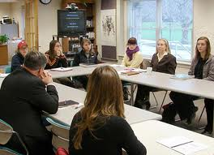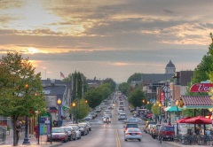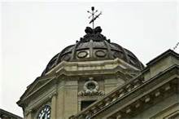

Academics:
- The program will focus on Business and Entrepreneurship in America, and will also include topics on governance, journalism, pop culture, sports, music, environment and more.
- Students will attend classroom and private lectures and have the opportunity to engage in discussion with peers and faculty.
- Many days will begin with language and vocabulary review specifically related to the topic of the day. These sessions are led by a trained ESL instructor.
- For participants interested in graduate study at an American university, there will be opportunities learn about application procedures, how to prepare for the GRE and TOEFL, visa requirements, and a general overview of graduate life.
- Throughout the session students will focus on a Group Project – creating a cohesive and entertaining summary of their experience abroad.

Site Visits:
- To reinforce study topics, students will meet experts in the field and participate in a variety of site visits which may include:
  - A range of businesses, including for profit, non-profit, and governmental
  - Mayoral and judicial offices
  - Museums and libraries
  - Newspaper, radio, and television studios
  - Theater, music concerts, and dance performances
  - Sporting events

Culture:
- Fun and team building recreational activities are planned to get students off campus and out into the countryside.
- Evening activities with peers such as film series, interactive discussions, or sporting activities will be an ongoing way for students to get to know American life and have time to interact with other students their own age.
- A “homestay” experience is the perfect finishing touch before leaving Bloomington for students to truly integrate into an American family, in a cross cultural sharing of their traditions and customs.
- Students will have daily access to IU’s impressive Student Recreational Sports Center (SRSC) as well as the opportunity to interact with students involved with the Chinese Flagship Program.

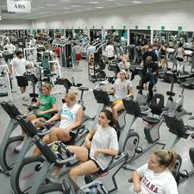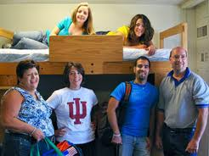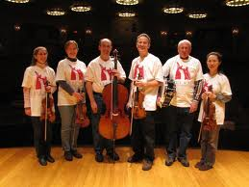

Housing:
Housing for the participants will be in multiple-occupancy rooms in the Teter Dormitory located on the Bloomington campus. Each student will be provided with a meal card to obtain meals on campus at either a cafeteria or food court. During the last few days in Bloomington, participants will be housed with an American family during a home-stay visit.

Recreation:
IU has one of the top-ranked Schools of Music in the US and many concerts are free and open to the public. Also, participants are encouraged to spend time playing pool or bowling at the Student Union or catch a movie at the IU Cinema. Students will receive an information packet upon arrival with night-life opportunities available in downtown Bloomington as well as happenings on-campus. During our trips to Indianapolis and Columbus there will be extra opportunity for dining and shopping into the evening hours.

A typical day at IU could look something like this:

8:00-9:00am Breakfast
9:00-10:00am Global Center Language and Culture
10:00-11:30am Campus Activity/Lecture
12:00-1:00pm Lunch
1:00-3:00pm Site Visits
3:00-5:00pm Group/Peer Activity
6:00-7:00pm Dinner
7:30-9:30pm Optional Evening Activity

July 31 -August 2: Students will take a three day trip to Chicago where they will receive a Chicago CityPASS and bus/train pass, giving them access to Chicago’s main sites as well as unlimited travel around the city. Staying in the well-known HI-Chicago (Hostelling International Chicago), participants will be right in the downtown heart of the city – in easy walking distance to the lake and many other attractions. Whether taking in the skyline, visiting the Shedd Aquarium, exploring Chinatown or trying famous Chicago Style pizza, students are sure to enjoy an authentic American experience.

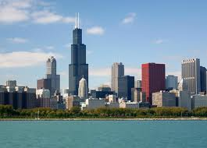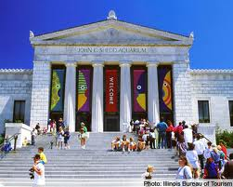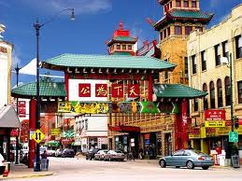

August 3-7: The summer tour will conclude in Washington DC with a four day educational trip to the capital city of the United States where students will meet with political figures as well as visit an incredible number of national landmarks. Students will stay at an international hostel, giving them the opportunity to meet other travelers from around the world. Home to the White House and National Monument, dozens of spectacular museums and other attractions, students are sure to have a fun packed three days of touring with their included pass on the DC Old Town Trolley – allowing them to stop and start at their leisure.

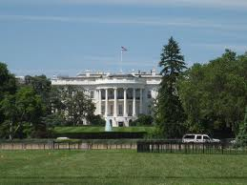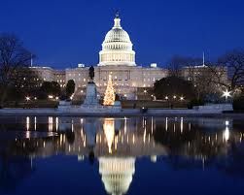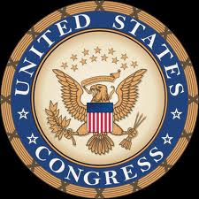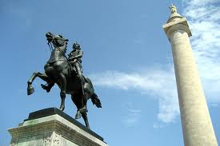

旅行愉快

我们会看到您的到来

Program includes:
- Individual U.S. cellular phones (one per participant)
- All lodging
- All meals while in BLOOMINGTON ONLY
- All program activities and city attraction passes
- All program related local transportation

Program participants are responsible for their own AIR TRAVEL, VISAS, HEALTH INSURANCE, and FOOD outside of Bloomington.

