HERTFORD COLLEGE
OXFORD

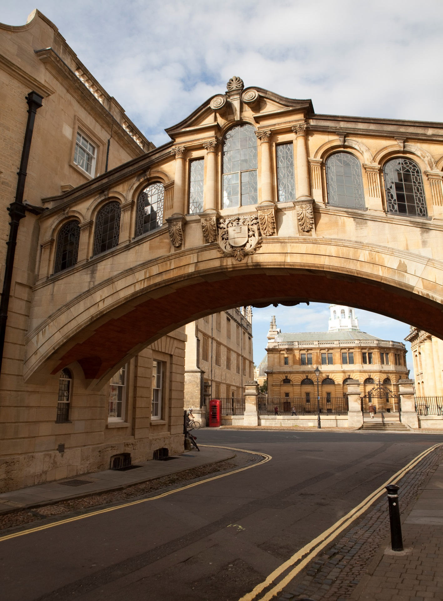

SUMMER 2016

ZHEJIANG UNIVERSITY

at

Hertford College, Oxford

Advanced English and Humanities Programme

SUMMER 2016

A very warm welcome to Hertford College and to Oxford!

Hertford College was founded in 1282 – it is one of the oldest of Oxford University’s 38 colleges. Located in the centre of historic Oxford, our beautiful college boasts the Bridge of Sighs, which is one of the most famous sights of the city. This is an ideal setting for students wishing to improve their language skills and knowledge of Britain and British culture.

Welcome to
Oxford!

MEALS

Meals:

- On class days you are offered breakfast, lunch and dinner.

- On trip days you are offered breakfast, a packed lunch and dinner.

- Weekend: Saturday you are offered breakfast. Sunday you are offered breakfast and dinner.

- On free-weekdays (Monday-Friday) you are offered breakfast, lunch and dinner.

The following pages outline your academic programme

WEEK ONE | 9.00 –10.30am |  |  | 11.00 – 12.30pm |  | 2.00-4.00pm |  | Evening
ARRIVAL DAY  Day 1  Sunday 10th July | - Arrive at Heathrow Airport, London.  - Hertford College Residential Advisors (RAs) will meet you.  - Travel to Oxford by private coach. You will stay in Oxford University Accommodation.  - On arrival: welcome meal and information
Day 2  Monday 11th July | Introduction to the Advanced English and Humanities Programme  English Language Assessment Students complete a placement test.  Communicative activities | B  R  E  A  K |  | An Introduction to Oxford and the University  Explore the development of the leading university in the English speaking world. | L  U  N  C  H | Welcome Tea at 3.00pm  Sample a delicious and traditional cream tea in the splendid surroundings of Hertford College’s historic dining hall.  Please wear smart clothes. Bring your camera! | D  I  N  N  E  R | Orientation  - Accommodation  - Facilities  - Connecting your computers to the internet
Day 3  Tuesday 12th July | Aspects of Oxford  Presentations by students based on the pre-course task. Each short presentation will be followed by a question and answer session. | B  R  E  A  K |  | Academic Writing 1  - Note-taking  - Introductions and conclusions  - Paraphrasing  - Supporting details: facts, quotations and statistics | L  U  N  C  H | Out and About Tour of Discovery  A self-guided exploration of the hidden corners of this beautiful city. | D  I  N  N  E  R | Cultural activities with RAs  (Suggestion: go for a walk by the river Thames)
Day 4  Wednesday 13th July | Presentations Workshop 1  - An introduction to student presentations  - How to plan and deliver a presentation effectively | B  R  E  A  K |  | Phonology  Connected speech in natural English: noticing and practicing assimilation and elision. | L  U  N  C  H | Oxford’s Famous Faces  Learn about some of Oxford’s well known scholars and public figures. | D  I  N  N  E  R | Cultural activities with RAs  (Suggestion: watch a Shakespeare play in an Oxford College garden)
Day 5  Thursday 14th July | Lecture  Self and Identity  An examination of how we view ourselves through the aperture of art, from the use of portraiture to ‘selfies’ | B  R  E  A  K |  | Activities and question session: Activate and expand your knowledge of the morning session. | L  U  N  C  H | Introduction to London  Learn about the history and cultural highlights of the capital city. You will also have the opportunity to study some of the treasures in the British Museum and National Gallery. | D  I  N  N  E  R | Cultural activities with RAs  (Suggestion: visit a traditional Oxford pub)
Day 6  Friday 15th July | Study Tour: London  Enjoy a trip to the capital city and experience all the magical sights and sounds of London in the comfort and safety of your private coach. You will have the opportunity to visit Parliament Square, the National Gallery and the British Museum.  You will be accompanied and guided by the RAs. Transport will be by private coach.
Day 7  Saturday 16th July | Weekend  At the weekend you have free time. If you wish to stay in Oxford, your RAs are available for Oxford activities, such as punting, walking tours, shopping, college and museum visits.  Alternatively, some students choose to travel independently to nearby places of interest such as:  - London  - Stratford upon Avon  - Warwick Castle  - Cambridge  - Bath  - Brighton  - Liverpool  These trips are not included in the programme price. Your RAs are available to offer advice and support about travel arrangements.
Day 8  Sunday 17th July | Free time (see Day 7)
WEEK TWO | 9.00 – 10.30am |  |  | 11.00 – 12.30pm |  | 2.00 – 4.00pm |  | Evening
Day 9  Monday 18th July | Who am I? - a creative-writing workshop to explore who you are and how others see you  Enjoy some teasing examples from the arts and literature to kick-start your own experiments with English wordplay. |  | B  R  E  A  K | Creative writing  Continued… | L  U  N  C  H | International Job Seeking Skills 1  - How to prepare for a job interview: personal statements and CVs  - How to research a company  - Interview role-play | D  I  N  N  E  R | Cultural activities with RAs  (Suggestion: attend an Oxford debating evening with students from other universities, facilitated by your RAs)
Day 10  Tuesday 19th July | Alice in Wonderland  A chance to explore the world of Lewis Carroll and meet the wonderful characters in this classic children’s story.  Students study the text and then discover how Alice has become an Oxford Tourist attraction. |  | B  R  E  A  K | The Ashmolean Museum  An in-depth look at the history and highlights of the University of Oxford’s remarkable collection. | L  U  N  C  H | The Ashmolean Museum  Complete a series of questions as you enjoy the beautiful exhibits. | D  I  N  N  E  R | Cultural activities with RAs  (Suggestion: go to a gig: jazz, blues, rock or pop in Oxford with your RAs)
Day 11  Wednesday 20th July | Academic Writing 2  - Comparison/contrast essays  - Active/passive voice in writing  - References and bibliography |  | B  R  E  A  K | Presentations Workshop 2  - Language check  - Body language  - Connecting with your audience  - Answering questions | L  U  N  C  H | British Culture  The History of the English Language  A study of the development of the English language throughout time | D  I  N  N  E  R | Cultural activities with RAs  (Suggestion: inter-collegiate sports evening)
Day 12  Thursday 21st July | British Culture  Festivals, Traditions and Folklore  Discover the secret histories and myths behind Britain’s best known and popular festivals. |  | B  R  E  A  K | Festivals, Traditions and Folklore  continued | L  U  N  C  H | Windsor Castle  Find out more about the history of this breathtakingly beautiful castle which has been the family home of British kings and queens for almost a thousand years. | D  I  N  N  E  R | Cultural activities with RAs  (Suggestion: listen to classical music at the Sheldonian Theatre or in an Oxford College or take part in a music session with RAs)
Day 13  Friday 22nd July | Study Tour: Windsor  You will have the chance to visit Windsor town and its historic castle—one of the Queen's favourite residences—which is reputed to be the largest inhabited castle in the world and also one of the oldest castles in the UK. Explore the streets and shops of this beautiful little town.  You will be accompanied and guided by the RAs. Transport will be by private coach.
Day 14  Saturday 23rd July | Weekend  Free time (as explained on day 7)
Day 15  Sunday 24th July | Weekend  Free time (as explained on day 7)
WEEK THREE | 9.00 – 10.30am |  |  | 11.00 – 12.30pm |  | 2.00 – 4.00pm |  | Evening
Day 16  Monday 25th July | Academic Debating Skills  - Expressing your opinion and comments  - Dis/agreeing  - Asking for/giving opinions  - Language of persuasion  - Turn-taking  - Rhetorical questions | B  R  E  A  K |  | Mini-debate  Work in teams to improve your intonation and practice your negotiation skills. You will also improve your confidence in public speaking. | L  U  N  C  H | Guided tour of the world famous Bodleian Library  You will visit the beautiful Divinity School, which was used as a location for the Harry Potter movies. | D  I  N  N  E  R | Cultural activities with RAs  (Suggestion: College tour - visit some of Oxford’s most renowned colleges)
Day 17  Tuesday 26th July | Current Affairs  Discover how newspapers capture the interest of their readers by creating effective headlines. | B  R  E  A  K |  | International Job Seeking Skills 2  - Business correspondence  - Cross cultural difference in the business world | L  U  N  C  H | Youth language, slang and idioms  Learn how social factors have shaped the language used by young people. | D  I  N  N  E  R | Cultural activities with RAs  (Suggestion: Film night)
Day 18  Wednesday 27th July | British Culture topic  History of modern pop music  An exploration of musical influences on modern culture, from the 1950’s – the present day | B  R  E  A  K |  | Presentations Workshop 3  - Fine-tuning of presentations  - Emphatic language  - Intonation and sentence/ word stress | L  U  N  C  H | Vocabulary Development  American vs British English  Explore the fascinating differences in vocabulary and pronunciation between these two major variants of English. | D  I  N  N  E  R | Cultural activities with RAs  (Suggestion: attend an evening lecture)
Day 19  Thursday 28th July | End of Course Presentations  Students deliver presentations in small groups before an audience. | B  R  E  A  K |  | End of Course Presentations  (continued) | L  U  N  C  H | Presentation Feedback Session | D  I  N  N  E  R | GALA DINNER  Celebrate your success at a memorable candle-lit dinner in the historic dining hall at Hertford College where you will be presented with a certificate at the end-of-course ceremony.  This is a special event so please wear smart clothes and bring your camera!
Day 20  Friday 29th July | Free day  Free time (as explained on day 7)
Day 21  Saturday 30th July | Departure day  You will be accompanied by the RAs in a private coach to the airport.

The International Programmes Department,
Hertford College,
Catte Street,
OX1 3BW

Tel: 01865 279 356

THE INTERNATIONAL PROGRAMMES DEPARTMENT

HERTFORD COLLEGE, OXFORD

