Fast Facts for Exchange Partners

The University of Manchester is:
- the largest single-site university in the UK, with the biggest student community (38,000).
- ranked 34th in the world; 8th in Europe; and 6th in the UK (2018 Academic Ranking of World Universities), with 83% of its research ranked as 'world-leading' or 'internationally excellent' by the Research Excellence Framework in 2014.

It’s the place where:
- 25 Nobel Prize winners have worked or studied
- Rutherford first split the atom
- Arthur Lewis became Britain’s first black professor
- Kilburn and Williams built the world’s first stored-program computer – The Baby
- Jevons formulated the principles of modern economics
- Lovell built the largest steerable radio telescope
- Geim and Novoselov isolated graphene for the first time

We have:
- 12,000 staff
- An annual income of £1.01 billion
- more than 1,000 degree programmes
- £345 million external research income
- A £1 billion campus investment over 10 years

The City of Manchester

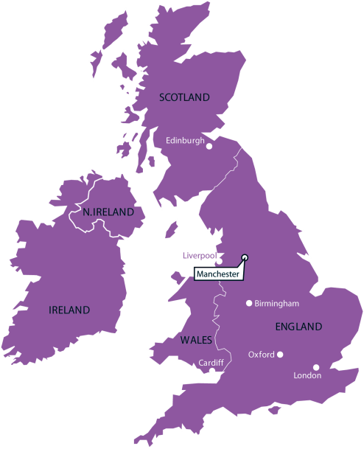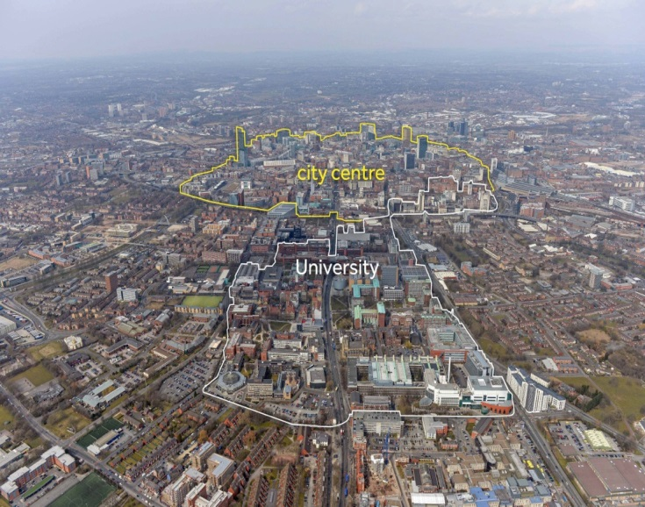

Greater Manchester:
- has a population of 2.5million, with the biggest student population in western Europe (more than 100,000)
- has the highest number of theatre seats per head of population outside London
- has the UK’s third busiest airport (after London Heathrow and London Gatwick)
- has an average annual rainfall of 806.6 millimetres (compared to the UK average of 1,125 millimetres)
- is the third most visited place in the UK and the second in England, after London
- was founded by the Romans more than 2,000 years ago
- is approximately 180 miles from London (approx. 2 hrs 10 mins by train)

Exchange Programme Key Information

Key Exchange Contacts:
Your students coming to Manchester | Amy Jones, International Programmes Administrator (Inbound Students) | Amy.jones-2@manchester.ac.uk | Tel: +44 (0)161 306 5626
Manchester students coming to your institution | Denise Whitehead, International Programmes Administrator (Outbound Students) | Denise.whitehead@manchester.ac.uk | Tel: +44 (0)161 275 3053
Matters relating to agreement | Caroline Whitehand, International Programmes Manager | Caroline.whitehand@manchester.ac.uk | Tel: +44 (0)161 275 3041

Address:
International Programmes Office, The University of Manchester, Oxford Road, Manchester, M13 9PL, England

Manchester Application Process:
Students must complete the online application reached via this site:
http://www.manchester.ac.uk/study/international/study-abroad-programmes/non-eu/how-to-apply/
Application deadlines are:
- 1 June – for September entry
- 1 November – for January entry

Housing information
University housing is guaranteed for students joining us for a full year. Students joining for a single semester are not guaranteed housing, but are almost always allocated it under normal circumstances. Application for housing is a separate, additional, online process, which students must complete AFTER receiving their offer letter from us - http://www.accommodation.manchester.ac.uk/applications/
Information on the type and costs of accommodation can be found via this link:
http://www.accommodation.manchester.ac.uk/

Key academic dates
http://www.manchester.ac.uk/study/international/study-abroad-programmes/non-eu/key-dates/
Alternative assessment arrangements are in place for almost all disciplines, other than the Engineering and Physical Sciences, if students joining the University for the Autumn/Fall semester are unable to stay in Manchester for the January Examination period due to conflicting semester dates at their home university.

Course unit enrolment
Students must submit a Proposed Study Plan as part of their online application, indicating the course units they wish to study whilst at Manchester. The International Programmes Office will then seek academic approval for students to take these units, and will enrol students onto course units where they are accepted. Students must not attempt to enrol themselves onto any course units. The course enrolment process begins no earlier than late July. Available course units can be found here:
http://www.manchester.ac.uk/study/international/study-abroad-programmes/non-eu/course-units/

Insurance requirements
The University of Manchester does not require that incoming exchange students purchase a specific insurance policy – students should source their own insurance according to their needs. Students applying for immigration permission to study in the UK for longer than six months will be required to pay a health care fee as part of the visa process; students will then receive free healthcare through the UK’s National Health Service.

Additional costs
Some course units incur additional costs. These include (but are not limited to):
- some course units (such as Geography) which incorporate a fieldwork trip
- some Music course units where additional Music lessons are required
- some lab-based course units

Emergency contacts
The University of Manchester has a 24 hour emergency contact point - +44 (0)161 306 9966

Additional Support
Support is available via The University of Manchester’s Disability Advice and Support Service (DASS). Information can be found here: http://www.dso.manchester.ac.uk/what-support-can-i-get/

Orientation
A detailed orientation programme is provided for students joining in each semester. Orientation is a mandatory part of the exchange programme and students must ensure they arrive in Manchester by the date specified in their offer documents to ensure they can participate.

Entry requirements
All students must have a GPA of 3.0 on a 4.0 scale (or equivalent) to be eligible for the exchange programme. Students whose first language is not English and whose degree programme is not taught entirely in English must also meet the English language requirements required by each subject area in which they wish to take course units: http://www.manchester.ac.uk/study/international/study-abroad-programmes/non-eu/entry-requirements/

Marking system
Students are graded on a percentage scale. Transcripts are sent to the International Programmes Office at students’ home universities. Students joining the programme for semester 1 only will receive an Interim Transcript in March, followed by an Official Transcript in late July. Students joining in semester 2 or for the full academic year will receive one transcript (Official Transcript) in late July/early August.

Exchange Programme website:
http://www.manchester.ac.uk/study/international/study-abroad-programmes/non-eu/

