ETM FACULTY



Engineering & Technology Management Department

Maseeh College of Engineering & Computer Science

Portland State University

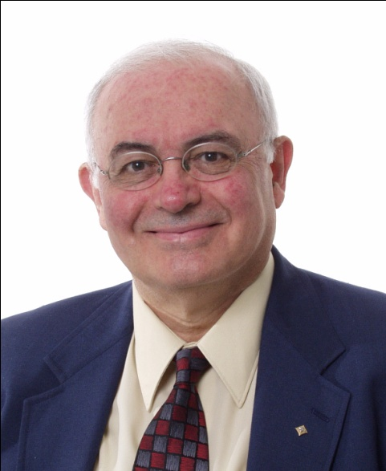
Dundar F. Kocaoglu, Ph.D, University of Pittsburgh
Professor and Chairman
kocaoglu@etm.pdx.edu

Areas of Interest: Technology Management, Emerging Technologies, Technology Selection, Sustainable Energy, Multicriteria Decision Making, Analytic Hierarchy Process (AHP), Resource Optimization, Project Management

Timothy R. Anderson, Ph.D., Georgia Institute of Technology
Associate Professor
tima@etm.pdx.edu

Areas of Interest: Data Envelopment Analysis (DEA), Productivity Management,
Manufacturing Management, Engineering Economic Analysis, Operations Research, Benchmarking, Technology Forecasting

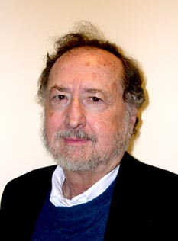
Frederick Betz, Ph.D., University of California, Berkeley
Adjunct Professor
fbetz@venture2reality.com

Areas of Interest: Strategic Management of Technology, Competitive Strategies, Executive Strategy, Management of Technological Innovations, Technology Management, Societal Modeling


Jeff Busch, B.S., University of Wisconsin at Stout
Adjunct Assistant Professor
busch@teleport.com

Areas of Interest: Project Management, Program Management, Project Scheduling, Financial Management of Projects, Portfolio Management, Disputes Management

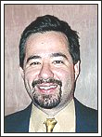
Tugrul U. Daim, Ph.D., Portland State University
Associate Professor and Program Director, Ph.D. Program
tugrul@etm.pdx.edu

Areas of Interest: Management of Energy Technologies, Technology Management, Technology Evaluation, Technology Acquisition, New Product Development, Technology Forecasting, Technology Roadmapping, R&D Management

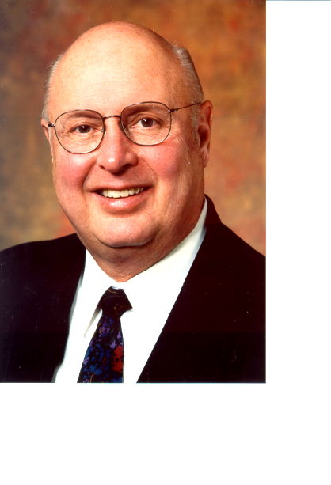
Robert D. Dryden, Ph.D., Texas Tech University
University Professor
drydenr@cecs.pdx.edu

Areas of Interest: Human Factors, Rehabilitation Engineering, Safety Engineering, Construction Productivity, Economic Analysis, Team Building, Communications

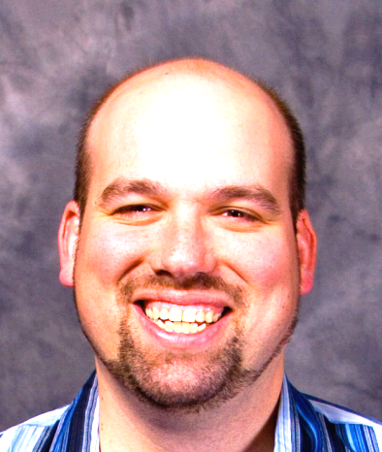
Ike Eisenhauer, M.Eng, Portland State University
Adjunct Assistant Professor
eisenhauer@statimetrics.com

Areas of Interest: Sustainable Quality Management, Adaptive Belief Management, Shared Resource Constrained DEA, Conflict Under Deceptive Rationality, Continuous Variable Prediction, Healthcare Systems Engineering


Mike Freiling, Ph.D., MIT
Adjunct Associate Professor
conceptrics@hotmail.com

Areas of Interest: Information Technology Management, Risk Analysis, Market Share Measurements

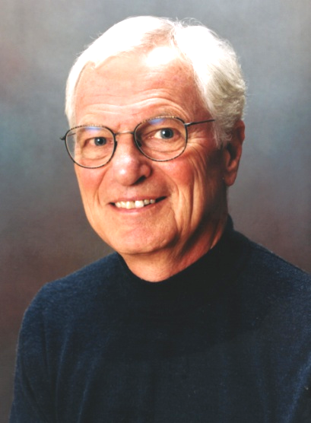
Carl Hollstein, MSEE, SUNY-Buffalo, Honors Co-op Grad. Prgm, Stanford Univ.
Adjunct Associate Professor
carl@chollstein.com

Areas of Interest: Supply Chain Management, Material Logistics, Vendor Relationships
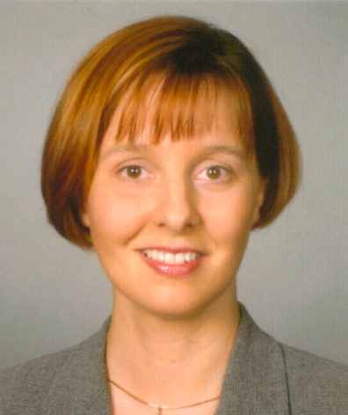
Antonie J. Jetter, Ph.D., Aachen University
Assistant Professor
jettera@cecs.pdx.edu

Areas of Interest: New Product Development, Fuzzy Front End of New Product Development, Open Innovation, Human Aspects of Technology Management, Entrepreneurship

Ron Khormaei, Ph.D., OSU
Adjunct Associate Professor
ron.khormaei@gmail.com

Areas of Interest: New Product Development, System Design and Manufacturing,
Strategic Alliances, Business Planning, New Business Creation

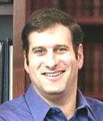
Scott A. Schaffer, J.D., University of Oklahoma
Adjunct Associate Professor
ScottSchaffer@techlaw.com

Areas of Interest: Intellectual Property Audits, Corporate Innovation, Patent Trolls,
Enforcement of IP Rights in Overseas Markets


Liono Setiowijoso, M.S., Portland State University
Senior Instructor
liono@etm.pdx.edu

Areas of Interest: Information Systems. Decision Support Systems, Hardware & Software Systems, Database Management Systems


Jan Mahar Sturdevant, PMP, M.S., Union College
Adjunct Senior Instructor
jms6@pdx.edu

Areas of Interest: Project Management, Project Planning and Implementation

Shimon Shmueli, MSEE, NYU-Poly; MBA, Wake Forest University
Adjunct Assistant Professor
shimon@touch360.com

Areas of Interest: Design and Innovation, New Product Development, Marketing and Branding, Design Thinking in Business and Product Management


Charles M. Weber, Ph.D., MIT
Associate Professor
charles.weber@etm.pdx.edu

Areas of Interest: Technology Innovation, Technology Entrepreneurship, Knowledge Management, Organizational Learning
Applications to the ETM Department are processed continuously throughout the year. On line-application forms are available at http://www.etm.pdx.edu/new/application/

