Honors Institute II Enrollment Form Guide
Step 1: Visit https://summersessions.georgetown.edu/enroll to begin your enrollment. Click “Enroll & Register” then click “Enroll” from the drop-down options.

Step 2: Click “Visiting Students”

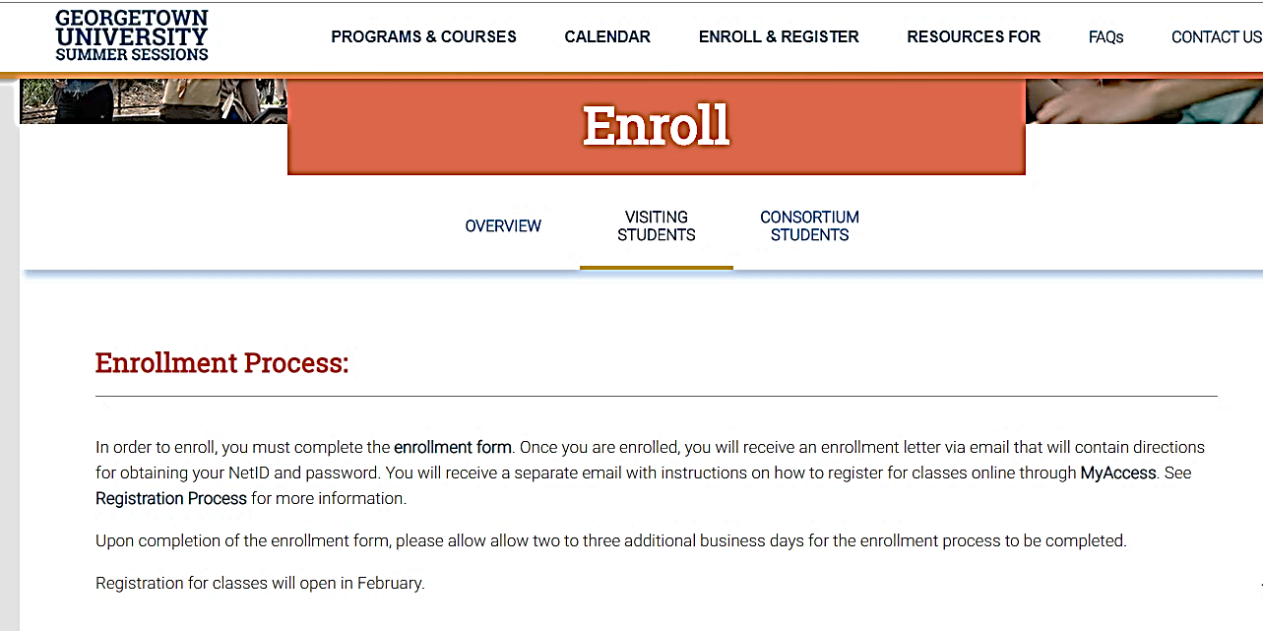
Step 3: Click “Enrollment Form” to begin your enrollment form. You will be directed to our online enrollment form.
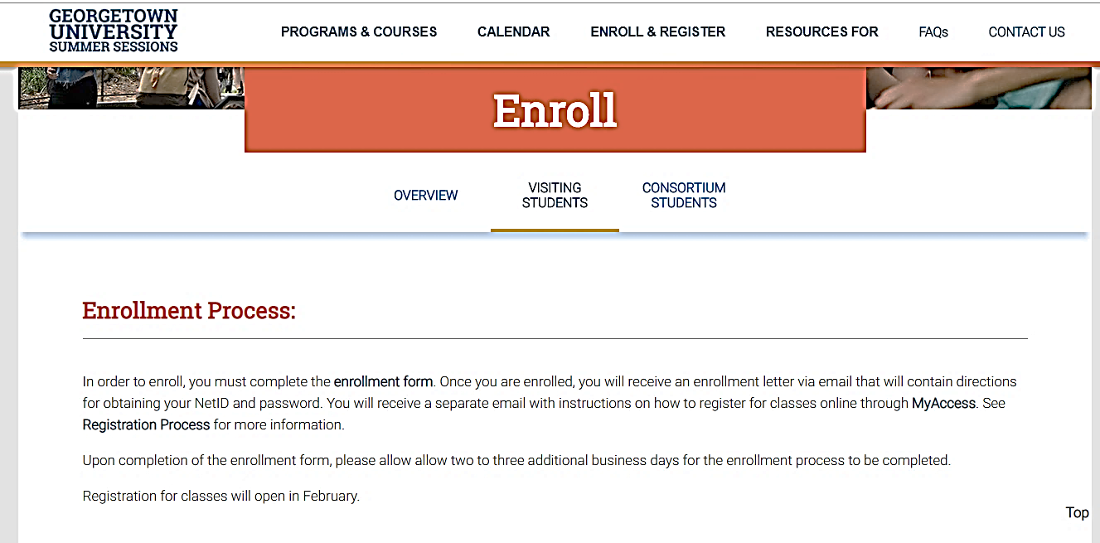

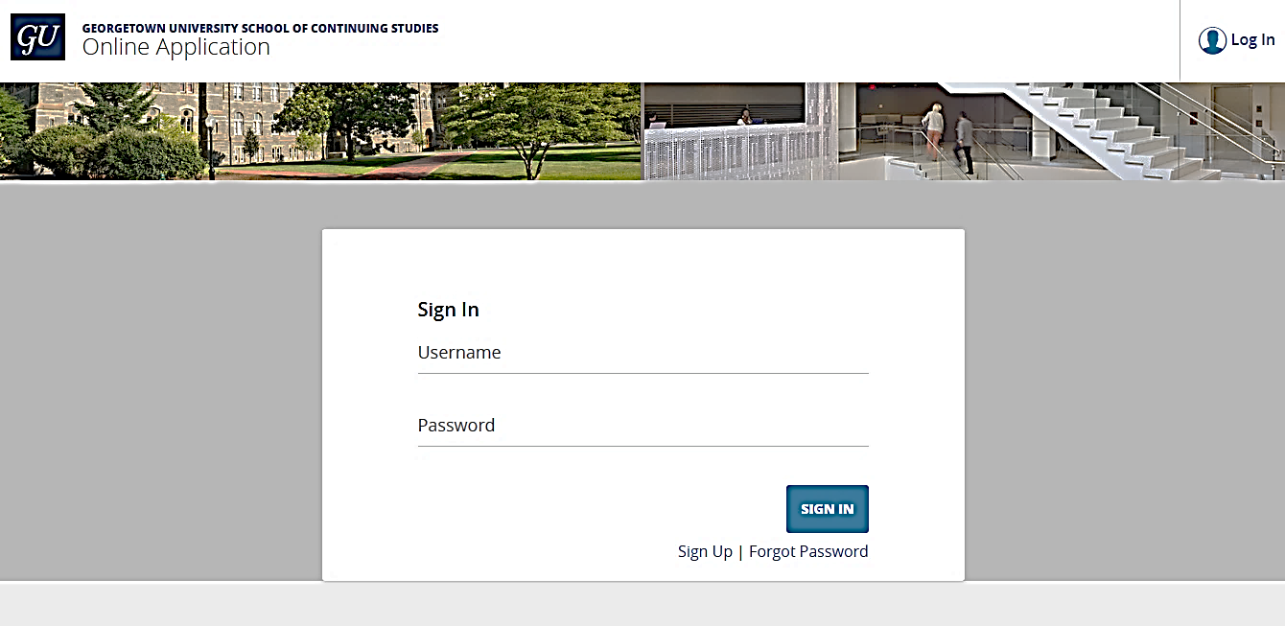
Step 4: On the enrollment home page, click “Sign Up”.

Step 5: Fill in your first name, last name, and email address. Check the box to indicate that you have read and agree to the SCS Terms of Use and Privacy Policy and then click “Submit”
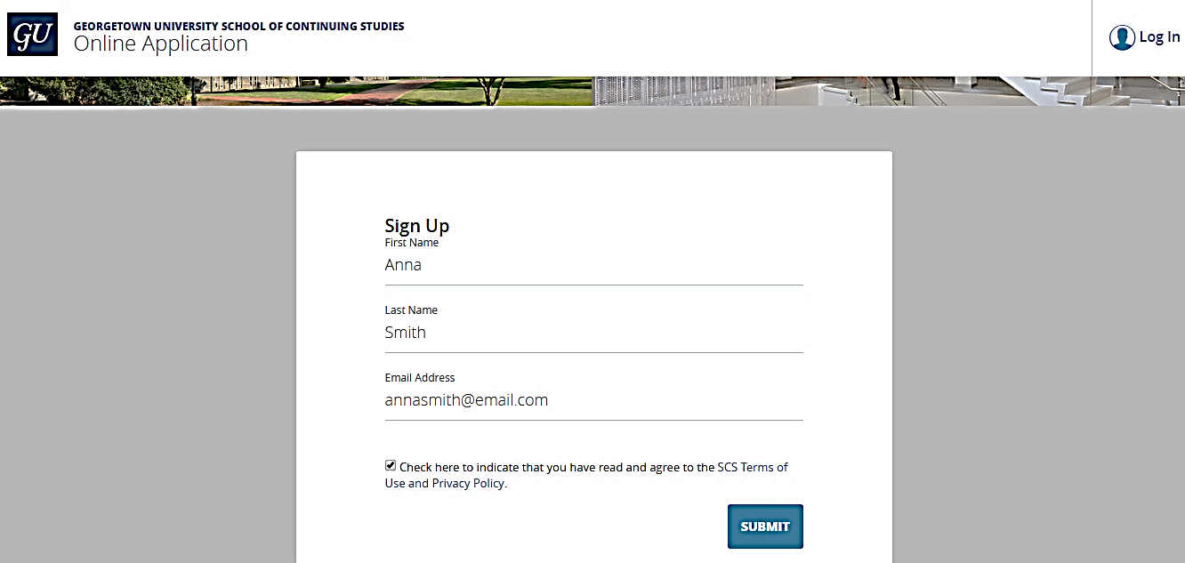

Step 6: Account Creation. You will receive a confirmation email. Click “Set Your Password” to create a password for your account.
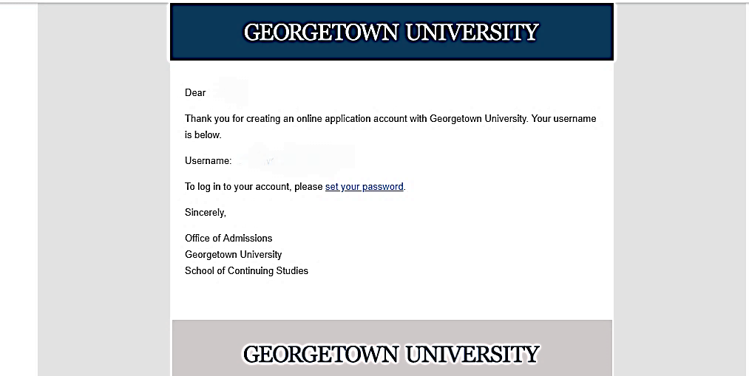
Step 7: Once you have created a password, enter your username and password and click “Sign In.”
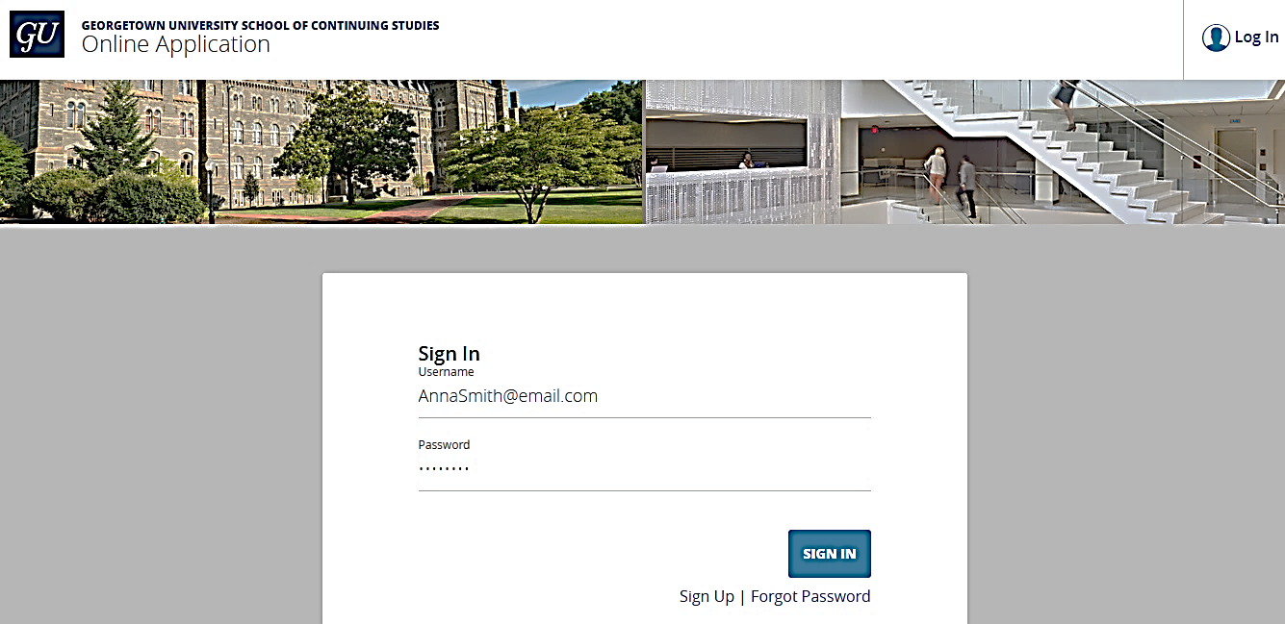

Step 8: Initiate your enrollment by clicking “Start A New Application.”
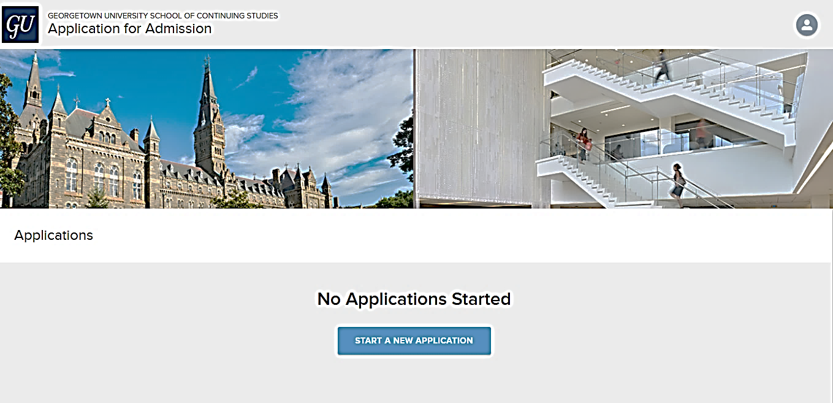

Step 9: Select “Undergraduate”, “Summer Sessions”, and “Summer 2019” then click “Start Application.”
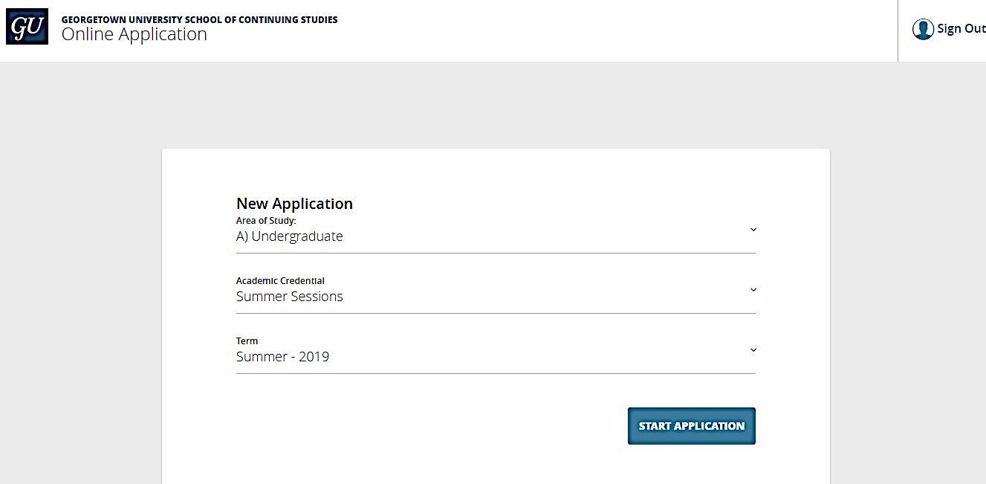

Step 8: In the following steps, you will first fill in information including “Personal Information”, “Contact Information”, and “Nationality and Citizenship Information”, “Background Information”, “Application Information”, and “Postsecondary Education Information.”
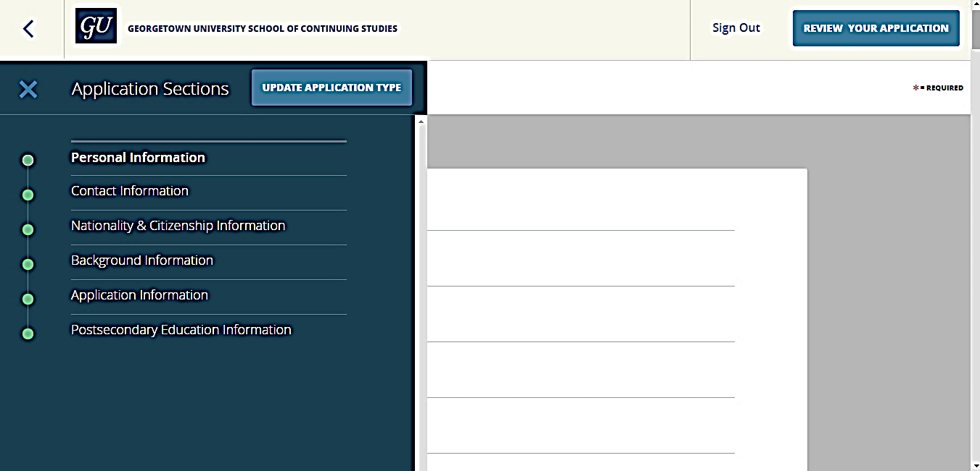

Personal Information Example
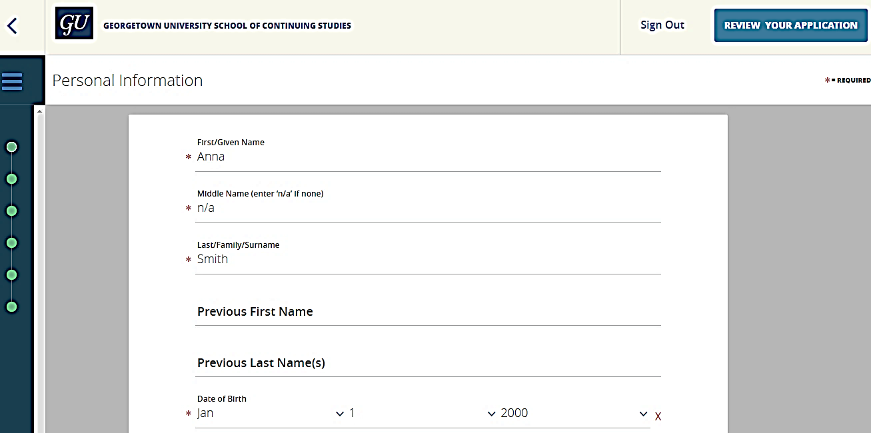

Step 9: Under “Nationality & Citizenship Information”, click “No file selected” to upload your TOEFL Score Report.” If you do not have your score reports available right now, you will be prompted to upload them later.
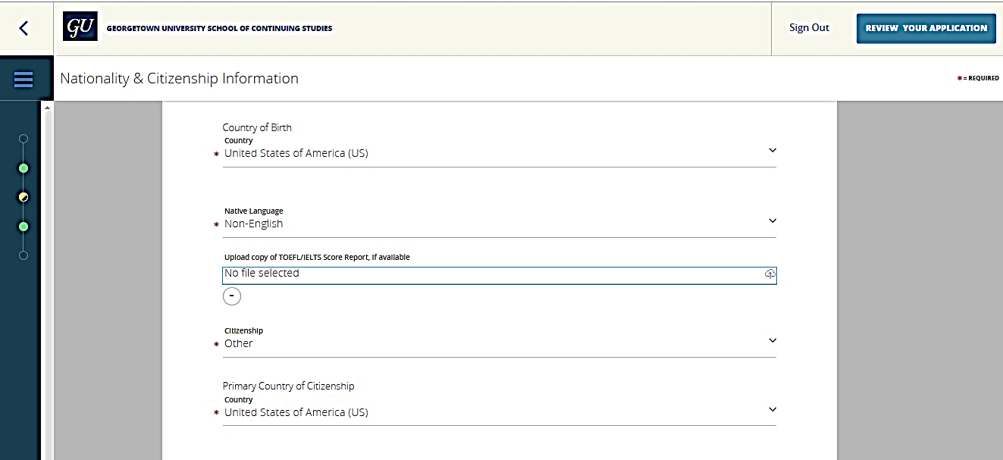

Background Information Example
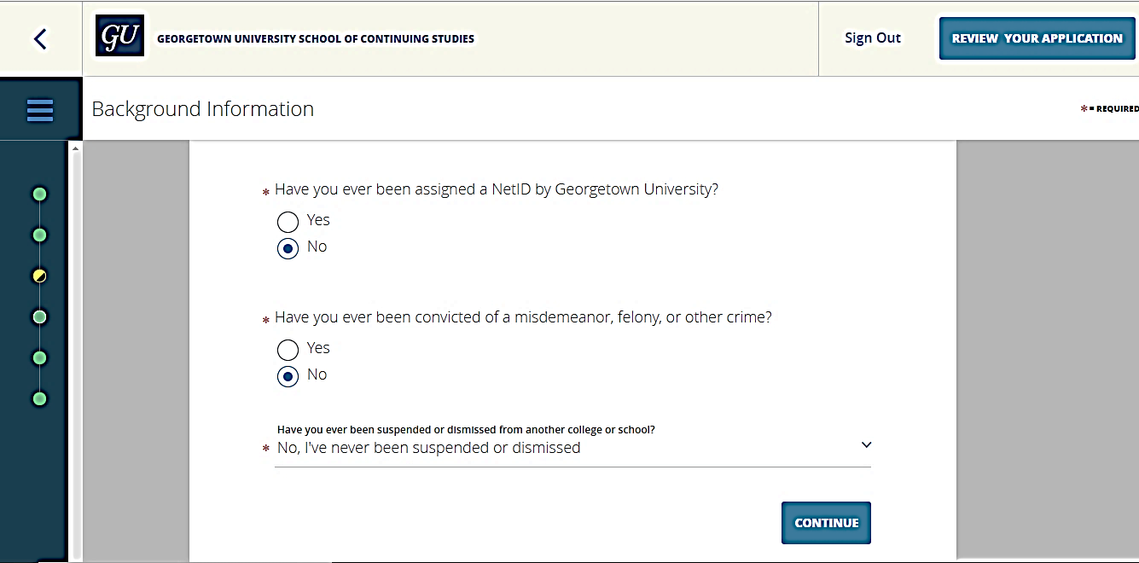

Step 10: Under Application Information, select “Honors Institute II”
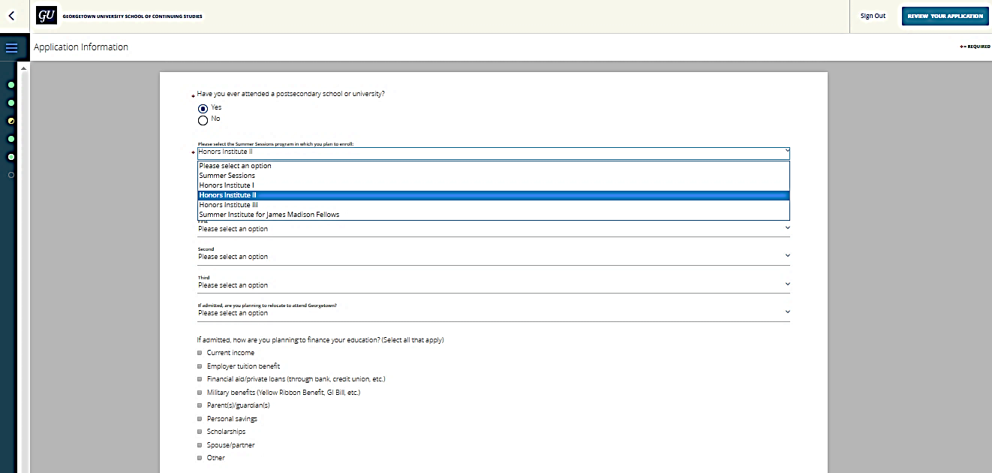

Step 11: Under “Postsecondary Information” enter the name of the institution you currently attend. You can add more institutions if you have attended more than one school.

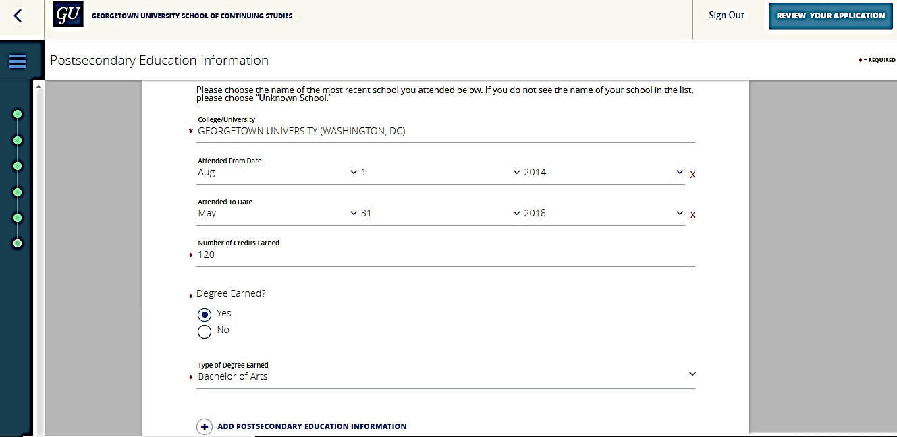

Step 12: When you have finished entering your information, please review and once complete, click “Submit Your Application.”

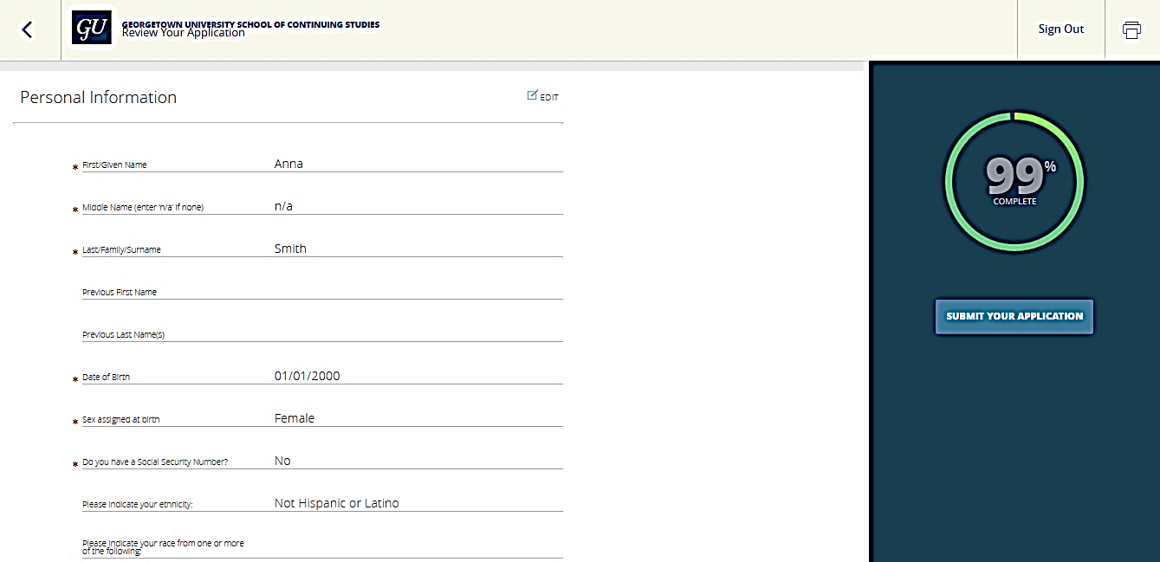
NOTE: “Scholarship Eligibility” section only applies to our degree programs.

Step 13: Verify and Submit. Enter your electronic signature and check the box to verify all the information in the form is true and correct. Last, click “Verify & Submit.”
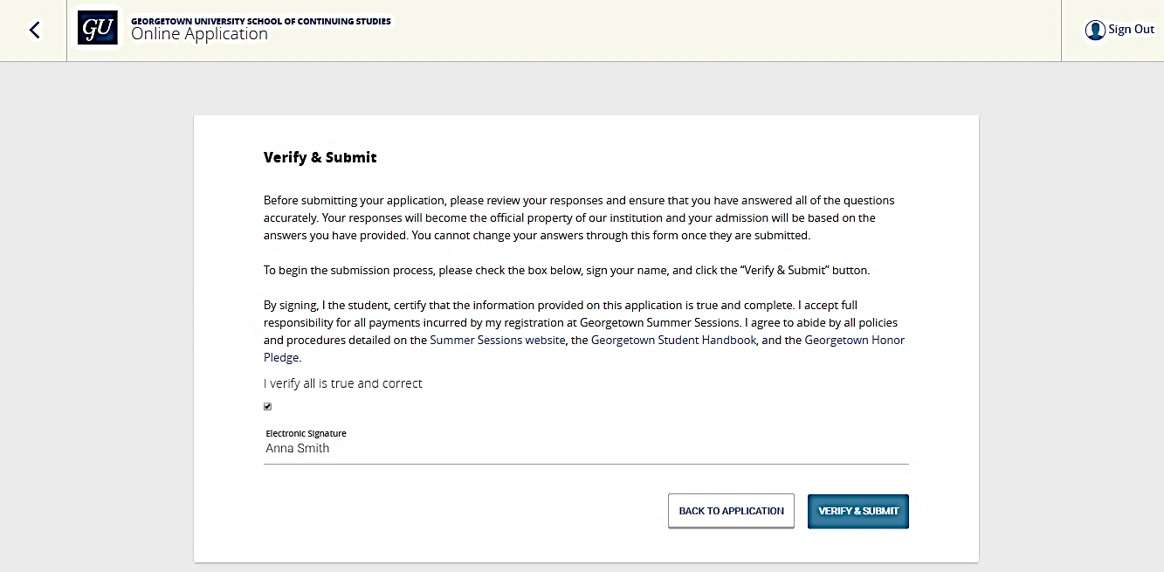

Step 14: Click “Return Home” to see if any additional items are required for your enrollment.
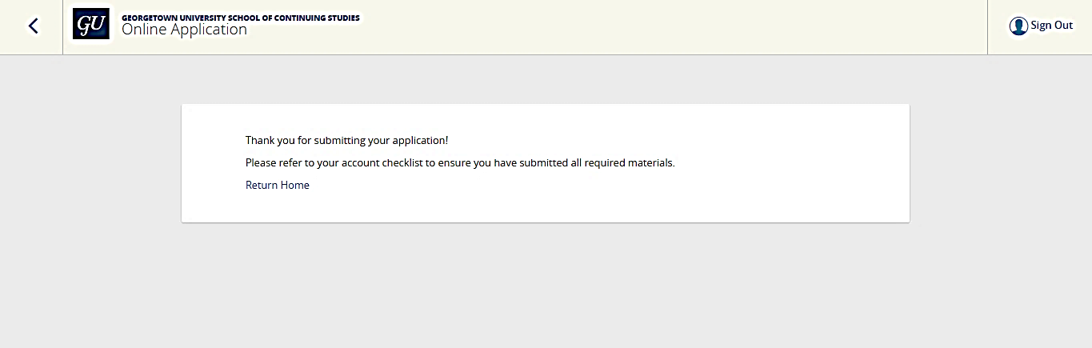
Step 15: On the “Checklist” you can see if there are any additional items needed to enroll in courses such as TOEFL Score Reports, as well as review your application, withdraw your application, or start a new application.
