We are delighted to announce we are running our International Summer School again in 2017.

The school lasts for 4 weeks and promises to be exciting, engaging and informative. The school is fully credit bearing which may be able to count towards your studies at your home university.

When you join the International Summer School 2017, you are booking your place as part of an internationally recognised centre for world-class research, enterprise and learning. Whilst with us you'll explore the UK and its culture and heritage - both through exciting study in the classroom and on the road in the many trips and excursions.You will take home fond memories of a cultural experience rooted in the hundred-year tradition of one of the UK's top universities.

Proposed topics for 2017  - Architecture of London  - British Explorers and Empire  - British Moral Philosophy  - Fashion – The age of Austen, Dickens and Brontë  - Guitars, Music and Culture  - Introduction to TESOL  - Jane Austen  - Monarchs: Icons of History  - The Real Downton Abbey  - Shakespeare  - Stonehenge and the Ancient World  - Women in Film |   (Image: previous summer school students on a visit to Stonehenge)
When you join the International Summer School 2017, you will study up to six exciting topics across the four weeks you are with us. Each topic is delivered by an internationally-recognised member of academic staff at the University of Southampton working in partnership with one of our many enthusiastic postgraduate research students. Across three engaging and interactive classroom sessions, they will introduce you to their topic of choice, explaining why it is important to them and offering you an insight into the world-class research environment they work in. You’ll find each topic is a friendly and engaging experience: you will normally study in groups with around 15 – 20 fellow students, allowing you to form good working relationships and have the opportunity to contribute and discuss in class.

How to book

It's very easy to secure your place for the International Summer School 2017. Simply visit our website (http://www.southampton.ac.uk/international_summer_school) and click the "Book now" button to pay the £500 deposit and secure your place, then one month before you join us we will request the balance of the fee which is from £3,250 including accommodation with a shared bathroom or £3,450 including en-suite accommodation.

The fee includes:  •Your place on up to six of the topics offered in this year's school  •Teaching in small, friendly groups of normally between 15 to 20 fellow students  •Meet and Greet from London Heathrow Airport and drop-off at the end of the course  •A single room within our university halls of residence from the duration of the summer school including bedding and other essentials  •Breakfast, lunch and evening meals during the week  •WiFi internet access in your room and around campus  •Transport and entry fees for all trips and excursions which feature as part of the course  •Barbeques, quizzes and social events as part of an exciting cultural programme  •Supporting material and information for each topic to take away  •A certificate of attendance  •On successful completion of the assessment, a transcript for 10 ECTS credits. | 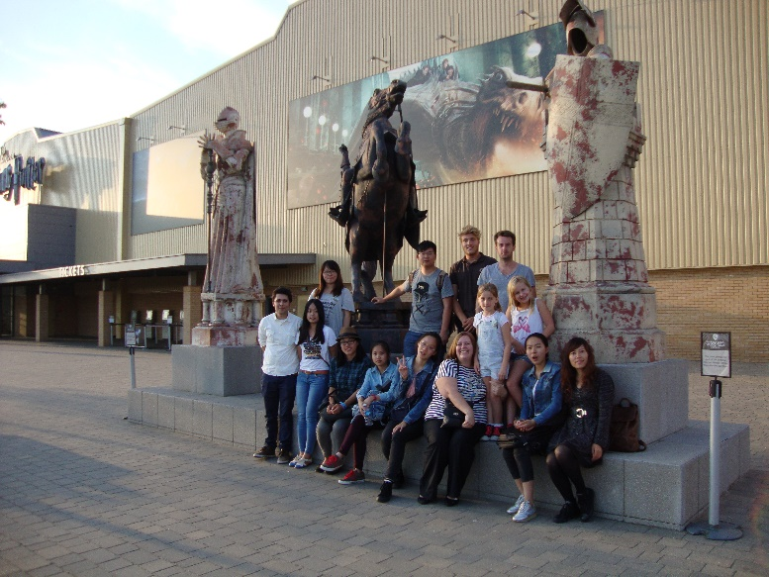  (Image: previous summer school students on a visit to Harry Potter Studios)  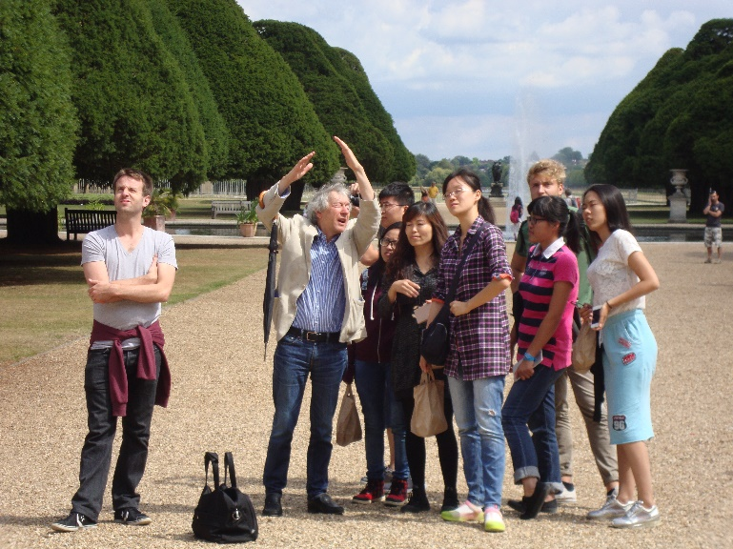  (Image: previous summer school students on a visit to Hampton Court Palace)

Entry Requirements:

To attend the school you will need to:

•Be a student currently studying at a recognised university outside of the UK.
•Be 18 years of age or older at the start of the school.
•Have IELTS 5.5 (or an equivalent English language qualification) in listening and speaking.

For further information please visit the website:
http://www.southampton.ac.uk/international_summer_school

If you have any further queries please contact Tracy Storey onsummerschool@southampton.ac.uk

Key Information

Course Length: 4 weeks

Location: University of Southampton and Southern England

Start date: Monday 17 July 2017

End date: Friday 12 August 2017

Accommodation: University Halls of Residence. Included in course fee

Food: Included in course fee (breakfast only at weekends)

Trips and Excursions: Included in course fee. See website for detailed itinerary

Airport Pick-up: Heathrow Airport. Saturday 15 July 2017

Airport Drop-off: Heathrow Airport. Saturday 13 August 2017

Application Deadline: 1 May 2017. Early application recommended.

Minimum Age Requirement: 18 or older on 15 July 2017

Entry requirements: IELTS 5.5 or equivalent qualification
Enrolled at a recognised international university

Price: £3,250 standard bedroom payable by 1 July 2017
£3,450 en-suite bedroompayable by 1 July 2017

Deposit: £500 on application

Topic, trip and social programme: Subject to change until 31 March 2017

Further Information: www.southampton.ac.uk/international_summer_school
summerschool@southampton.ac.uk

Academic Credit 10 ECTS credits awarded by the University of Southampton after successful completion of associated assessment

